

No: 12. 2012/13 Cropping Season December 21- 31, 2012

HIGHLIGHTS
Crops over both unimodal and bimodal areas are expected to benefit from normal rainfall although over unimodal areas where above normal rains are expected, there is a likelihood of excessive soil moisture levels mainly over low lying fields resulting into leaching of nutrients, hence affecting crop management. For daily farm operations farmers are advised to follow daily weather forests issued by the Tanzania Meteorological Agency.

SYNOPTIC SUMMARY

D
uring the third dekad of December, 2012, the southern hemisphere high pressure cells (anticyclones) were noted to observe gradual relaxation. On the other hand, Azores anticyclone and Siberian high and the associated Arabian ridging over the northern hemisphere were noted to significantly intensify with time. As a result, the Meridional arm of the Inter-Tropical Convergence Zone (ITCZ) was slightly located over the western side of the country while the zonal arm of the ITCZ moved southwards to southern sector of the country. These settings caused penetration of the north-easterlies over some parts of the country, thus influenced rainfall over Lake Victoria basin, western regions, north-eastern highlands and northern coast regions. Sustained warm and cool sea surface temperature (SST) pattern was observed over the eastern Indian Ocean and central Indian Ocean respectively while warm to neutral conditions was observed over western Indian Ocean. The overland ridge from southern Africa was generally relaxed, allowing penetration of the easterlies to southeasterlies towards the Tanzania coastal line thus causing showers over some parts of the coastal regions.

RAINFALL SUMMARY

During the third dekad of December 2012, moderate rains were recorded over most parts of the country with higher values concentrated over central areas and north-eastern areas as indicated in Figure 1a. The highest rainfall amount for the period was recorded at Singida Met station in the central region, (137.9 mm), followed by Matangatuani in Pemba Isles, (130.6 mm), Kibondo (125.5 mm), Mugumu (122.5 mm), Babati (121.8 mm), Tabora (105.1 mm), Lyamungu (90.4 mm), Sumbawanga (86.4 mm), Dodoma (81.0 mm), Mbozi (74.1 mm), Tumbi (73.2 mm), Mwanza 73.1 mm), Songea (67.8 mm), Igeri (65.0 mm), Mahenge (63.7 mm), Pemba (58.4 mm), Arusha (56.1 mm), Ukiriguru (53.4 mm), Dar es Salaam JNIA (51.8 mm), and Zanzibar (50.6 mm). Other parts of the country experienced rainfall amounts less than 50 mm as shown in Figure 1a. Likewise, the Geospatial Water Requirement Satisfaction Index (GeoWRSI) model with inputs from Satellite Rainfall Estimates (RFE) merged with gauge data from Tanzania rainfall stations network also indicates similar pattern of the rainfall performance during the dekad whereby parts of central and northeastern highlands, and much of the eastern and southern sectors of the country experienced rainfall below 50% of long term average as shown in Figure 1b.
Figure 1a: December 21-31, 2012 Rainfall distribution (mm)
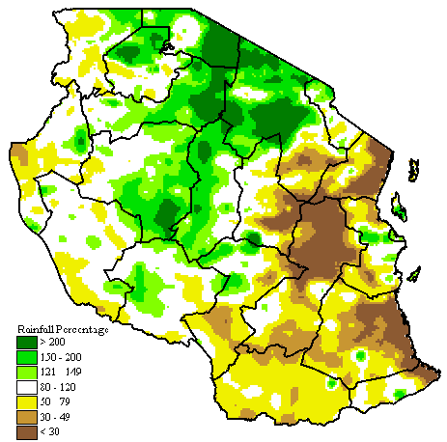
Figure 1b: December 21-31, 2012 Percent of Average Rainfall from GeoWRSI.

IMPACT ASSESSMENT

Agrometeorological and Crop Summary
I
mproved soil moisture was experienced over pew parts of the country during the dekad, except for the central, eastern, and southern sectors where soil moisture deficits were recorded. Early planted crops including maize and beans over parts of Lake Victoria basin particularly Kagera and Mara regions were observed at advanced growth stages ranging from ninth leaf to near tasselling as for maize, while budding to wax ripeness stage for beans and their state was rated good to moderate. Crops that were affected by soil moisture deficit as observed over parts of Kilimanjaro region particularly over Lyamungu, Moshi and Same areas in the northeastern highlands were generally in poor to moderate state. However, over the unimodal rainfall pattern particularly; central, southwestern highlands, southern region and southern coast the moderate to substantial soil moisture obtained was beneficial for planting and crop establishment being the major field activities during the dekad.
Pastures and water availability for livestock and wildlife have improved over much of the country.

Hydrological Summary
Water levels in dams and river-flow had not changed much due to moderate distribution of the rainfall experienced over some parts of the country during the dekad.
Environmental Summary
Temperatures remained generally high over much of the country as well as warm to humid air observed mainly over the coastal areas that occasionally caused discomfort.

Prepared by
TANZANIA METEOROLOGICAL AGENCY (TMA)
3rd, 4th, &10th Floors - Ubungo Plaza – Morogoro Road.
P.O. Box 3056 Tel. 255 -(0) 22 – 2460706-8 ; Fax: 255 - (0) 22 – 2460718 E-mail:
(1) met@meteo.go.tz (2) agromet@meteo.go.tz
Dar es Salaam UNITED REPUBLIC OF TANZANIA

EXPECTED SYNOPTIC SYSTEMS

DURING JANUARY 1-10, 2013

During the period, the southern pressure systems particularly the Mascarene are expected to continue relaxing while their counterparts to the north are expected to continue intensifying, thus strengthening the ITCZ over unimodal areas of the country especially over western, southwestern highlands, southern regions, southern coast regions and adjoining areas of central regions of the country.

EXPECTED WEATHER

DURING JANUARY 1-10, 2013
L
ake Victoria basin (Kagera, Mwanza, Mara, Geita, Simiyu and Shinyanga regions), northeastern highlands (Kilimanjaro, Arusha and Manyara regions), and northern coast (Dar es Salaam, Morogoro and Tanga regions, the Isles of Zanzibar and Pemba) are expected to feature normal rains. Western regions (Kigoma and Tabora regions), central areas (Dodoma and Singida regions), southwestern highlands (Rukwa, Iringa and Mbeya regions), southern coast (Mtwara and Lindi regions), and southern region (Ruvuma region) are expected to experience normal to above normal rains.

AGROMETEOROLOGICAL OUTLOOK FOR JANUARY 1-10, 2013
D
uring the dekad, crops over both unimodal and bimodal areas are expected to benefit from normal rainfall although over unimodal areas where above normal rains are expected, there is a likelihood of excessive soil moisture levels mainly over low lying fields resulting into leaching of nutrients, hence affecting crop management. For daily farm operations farmers are advised to follow daily weather forests issued by the Tanzania Meteorological Agency.

