

No: 11. 2012/13 Cropping Season December 11- 20, 2012

HIGHLIGHTS
Crops over both unimodal and bimodal areas are expected to benefit from normal rainfall although over unimodal areas where above normal rains are expected there is likelihood of excessive soil moisture levels over low lying fields and leaching of nutrients, hence affecting crop management. For daily farm operations farmers are advised to follow daily weather forests issued by the Tanzania Meteorological Agency.

SYNOPTIC SUMMARY

D
uring the second dekad of December, 2012, the southern hemisphere high pressure cells were gradually relaxing. On the other hand, Azores anticyclone and Siberian high and the associated Arabian ridging over the northern hemisphere were noted to significantly intensify with time. As a result, the Meridional arm of the Inter-Tropical Convergence Zone (ITCZ) was slightly pushed towards the west while the zonal arm moved south wards from its previous position. These settings led to penetration of the north-easterlies over some parts of the country, thus influenced rainfall over some parts of the country (Lake Victoria basin, Western regions, northeastern highlands and northern coast regions). Sustained warm and cool sea surface temperature (SST) pattern was observed over the eastern and central Indian Ocean respectively, while western Indian Ocean indicating warm to neutral conditions. The overland ridge from southern Africa was generally relaxed, allowing penetration of the easterlies to south-easterlies towards the Tanzania coastal line that were associated with showers over some parts of the coastal regions.

RAINFALL SUMMARY

D
uring the second dekad of December, 2012, moderate rains were recorded over some parts of the country as indicated in Figure 1a. The highest rainfall amounts for the period was recorded at Kilwa Masoko (174.5 mm) in the southern coast, followed by Sumbawanga (103.1 mm), Tukuyu (111.7 mm), Tabora (93.1 mm), Bukoba (91.9 mm), Pemba (77.8 mm), Mpanda (69.9 mm), Handeni (67.1 (mm), Ilonga (66.6 mm), Namanyere (66.4 mm), Mahenge (65.2 mm), Same (63.5 mm), Mugumu (62.5 mm), and Tumbi (61.5 mm). However, much of the country reported less than 50 mm of rainfall with some pocket areas over central, northern coast and northeastern highlands experiencing much less rainfall for the period as shown in Figure 1a. The Geospatial Water requirement Satisfaction Index (GeoWRSI) model with inputs from Satellite, the Satellite Rainfall Estimates (RFE) and gauge data from Tanzania rainfall stations networks indicates poor rainfall performance (less than 50% of long term average) during the dekad for areas over northern coast (Dar es Salaam, Coast, and Tanga (southern) regions, and Islands of Zanzibar), central (Singida and Tabora regions), Lake Victoria basin (Shinyanga, Mwanza, and Mara regions), and northeastern highlands (Manyara and Arusha regions) as shown in Fig. 1b.
Figure 1a: December 11-20, 2012 Rainfall distribution (mm)
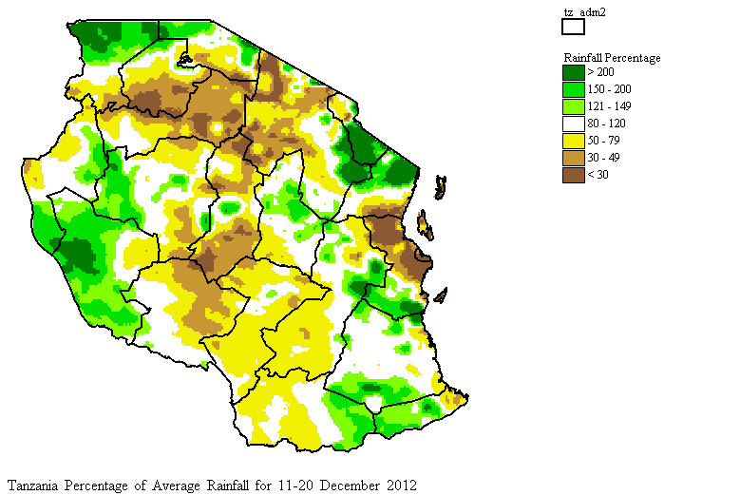
Figure 1b: December 11-20, 2012 Percent of Average Rainfall calculated from Geospatial Water Requirement Satisfaction Index (GeoWRSI) model with inputs from satellite estimated rainfall (RFE) and gauge data.

IMPACT ASSESSMENT

Agrometeorological and Crop Summary
I
nadequate soil moisture supply experienced over much of the country mainly the northeastern highlands, Lake Victoria basin, northern coast, and central regions hampered crops at different growth stages. Early planted crops including maize and beans over parts of Lake Victoria basin particularly Kagera and Mara regions were observed at stages ranging from ninth leaf to near tasselling for maize, while budding to wax ripeness stage for beans, and both appeared in good to moderate state. Most crops were negatively affected by soil moisture deficit that occurred over parts of Kilimanjaro region largely towards the end of the dekad. Other areas in the sector contained crops at emergence stage as for beans observed particularly over Lyamungu and Moshi in the northeastern highlands that were generally in poor to moderate state due to soil moisture stress experienced for the period. However, in the unimodal rainfall pattern particularly; central, southwestern highlands, southern region and southern coast experienced moderate to substantial soil moisture supply were beneficial for planting and crop establishment as the leading field activities over the region during the dekad.
Pastures and water availability for livestock and wildlife have improved over much of the country.

Hydrological Summary
Water levels in dams and river-flow had not changed much due to poor rainfall distribution experienced over some parts of the country during the dekad.
Environmental Summary
Temperatures remained generally high over much of the country as well as warm to humid air observed mainly over the coastal areas that occasionally caused discomfort.

EXPECTED SYNOPTIC SYSTEMS

DURING DECEMBER 21-31, 2012
Prepared by
TANZANIA METEOROLOGICAL AGENCY (TMA)
3rd, 4th, &10th Floors - Ubungo Plaza – Morogoro Road.
P.O. Box 3056 Tel. 255 -(0) 22 – 2460706-8 ; Fax: 255 - (0) 22 – 2460718 E-mail:
(1) met@meteo.go.tz (2) agromet@meteo.go.tz
Dar es Salaam UNITED REPUBLIC OF TANZANIA

During this period, the southern pressure systems particularly the Mascarene are expected to continue relaxing while their counterpart to the north are expected to continue intensifying, thus strengthening the ITCZ over unimodal areas of the country, especially over western, southwestern highlands, southern regions, southern coastal regions and adjoining areas of central regions of the country.

EXPECTED WEATHER DURING

DECEMBER 21-31, 2012

Lake Victoria Basin (Kagera, Mwanza, Mara, Geita, Simiyu and Shinyanga regions), northeastern highlands (Kilimanjaro, Arusha and Manyara regions), and northern coast (Dar es Salaam, Morogoro and Tanga regions, the Isles of Unguja and Pemba), and southern Coastal (Mtwara and Lindi regions) are expected to feature normal rains. Western regions (Kigoma and Tabora regions), central areas (Dodoma and Singida regions), southwestern highlands (Rukwa, Iringa and Mbeya regions), and southern region (Ruvuma region) are expected to experience normal to above normal rains.

AGROMETEOROLOGICAL OUTLOOK FOR DECEMBER 21-31, 2012

D
uring the dekad, crops over both unimodal and bimodal areas are expected to benefit from normal rainfall although over unimodal areas where above normal rains are expected there is likelihood of excessive soil moisture levels over low lying fields and leaching of nutrients, hence affecting crop management. For daily farm operations farmers are advised to follow daily weather forests issued by the Tanzania Meteorological Agency.

