 **SVG MONTHLY WEATHER B U L L E T I N**  **Volume 5 Issue 8** **August 2015**

**ANNOUNCEMENTS…. CIMH joined disaster response efforts in Dominica for relief of widespread damage caused by Tropical Storm Erika. A drought watch continues to be in effect for Saint Vincent. View Agro- met bulletins around the world… For more information, visit the CIMH website.** [**www.cimh.edu.bb**](http://www.cimh.edu.bb)

**August 2015 Summary:**

**National Rainfall Outlook:**

September to November 2015: Rainfall totals expected to be below normal to normal. **(See figure 2.)**

108

101

On August 22nd, Hurricane Danny became the first hurricane of the 2015 Atlantic season reaching a category 3 hurricane before dissipating on the 24th in the Caribbean Sea. It posed no threat to Saint Vincent and the Grenadines. Thereafter, on the 24th, tropical storm Erika was formed. It reached peak intensity with winds of 50mph on multiple occasions. It produced significant flooding and gusty winds across Dominica causing disruption and even deaths. In St. Vincent, damage to one house roof in Ottley Hall was reported. Figure1.Stations- Rainfall (mm)

**Temperature Outlook:**

Air Temperature- Above normal to normal

Sea Surface Temperature- 0.5 -1 °C above average.

142



22

227

257

258

169

Tropical waves affected Saint Vincent and the Grenadines resulting in 22.3 mm of rainfall at the E. T Joshua station on the 12th and 29.1mm on the 29th. Moderate to strong breeze affected the islands and as a result seas were moderate to occasionally rough in open waters. **Maximum gusts** in the Arnos Vale area were recorded on the 12th as 33 knots (~61km/h). Hazy conditions also persisted throughout August.

Table 1. August 2015 Rainfall and Temperatures across SVG

|  |  |  |  |  |
| --- | --- | --- | --- | --- |
| **Key Fig.1** | **Station - Location** | **Rainfall**  ( **mm**) | **Max.** **Temp.**  (**o C**) | **Min.** **Temp.**  ( **o C**) |
|  | **Arnos Vale - Airport** | 142.4 | 32.2 | 24.4 |
|  | **Langley Park** | 121.3 | 31.3 | 22.6 |
|  | **Belle Isle** | 177.5 | 31.2 | 22.1 |
|  | **Richmond** | 189.5 | 32.8 | 23.1 |

|  |  |  |  |  |
| --- | --- | --- | --- | --- |
| **E. T. Joshua Airport Station** | **Rain-days** | **Rainfall**  **mm** | **Mean RH**  **%** | **Max/Min Temp. o C** |
| **August** | 14 | 142.4 | 76 | 32.2/24.4 |
| **30 year average\*** | 20 | 237.0 | 77.9 | 31.9/22.9 |

Table 2. Comparison of Parameters at E.T. Joshua Airport Station

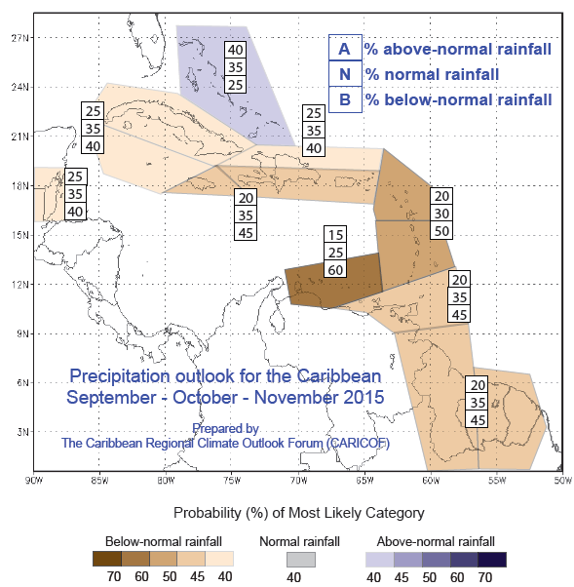

Figure 2 Regional Precipitation Outlook September – October- November 2015 [*Read more.*](http://www.cimh.edu.bb/?p=precipoutlook)

Average rainfall for September is 243.9mm with 18 rain-days (using E.T Joshua Airport 1981-2010 period average).The average maximum temperature is 32.3⁰C and the average minimum temperature is 23.0⁰C. Due to increase strong wind shear in the Atlantic, fewer hurricanes are expected to formed, however this does not mean that they will be less deadly. We must always be prepared!

**MoonPhases2015:**September**:** FMFull Moon lunar phase 27th LQLast Quarter Moon lunar phase 5th NM New Moon lunar phase13th FQFirst Quarter Moon lunar phase 21st October: FMFull Moon lunar phase 27th LQLast Quarter Moon lunar phase 4th NM New Moon lunar phase 12th FQFirst Quarter Moon lunar phase 20th

This bulletin was prepared by the E.T. Joshua Airport - Aeronautical Meteorological staff. Contact us for more detailed information on parameters monitored.   
We welcome feedback, suggestions and comments, write to: Director of Airports, E.T. Joshua Airport, Arnos Vale, St. Vincent.

E-mail address: [airportsdep@gmail.com](mailto:airportsdep@gmail.com) or [svgmet@gmail.com](mailto:svgmet@gmail.com) page 1of 1