MINISTRY OF NATURAL RESOURCES, ENERGY AND MINING
Department of Climate Change and Meteorological Services

STATEMENT ON WEATHER UPDATE AS FROM 22 TO 30 MAY 2016
As from Sunday 22nd May up to Monday 23rd May 2016, chilly weather conditions associated with patches of rain drizzle over highlands locally known as Chiperoni weather condition caused by an influx of relatively cool and moist airflow from the south east brought into Malawi by a huge high pressure area traversing through the southern tip of the Republic of South Africa is going to persist. The Chiperoni weather will be accompanied with fog in low lying areas and high ground with fresh to strong Mwera wind over Lake Malawi.

From Tuesday 24 May to Wednesday 25 May 2016 a gradual pick up in day time temperatures is likely across the country as cool south easterlies are replaced by warm easterlies.

As from Thursday 26th May 2016 up to Saturday 28th May 2016, another wave of Chiperoni weather is expected over the country, with fog in low lying areas and uplands accompanied by an outburst of moderate to fresh Mwera wind over Lake Malawi.

As from Sunday 29th May to Monday 30th May 2016 partly cloudy and warm weather conditions during day time is expected.

Otherwise Cold nights and locally very cold mornings are expected daily over the country during the whole period.
The type of weather we get during any seasons is controlled by the temperature we receive from the sun. As the temperature is the result of the amount of heat energy we receive from the sun which always shines towards the equator. The difference in temperature between the summer and the winter is due to the tilt of the Earth’s axis.
During the winter, the sun's rays hit the Earth at a shallow angle because planet earth tips over to one side by about 23.5 degrees. This tilt of the planet affects the way that the sun shines us, where the sun rays are more spread out, coming in at a shallow angle with more of the atmosphere to filter through minimizing the amount of heat energy that hits us. As the temperature is the result of the amount of heat energy we receive from the sun which always shines towards the equator, during day time during winter, the sun is lower in the sky and the heating during day times get shorter because the southern hemisphere of the earth is tilted away from the sun. The long nights and short days provide fewer hours of sun during day time resulting in less warming of the atmosphere in winter than in the summer.
Climatologically winter season in Malawi started on 1st May 2016. During the winter season the frequent passages of huge high pressure areas from the Atlantic Ocean into the Indian Ocean through the south east coast of the Republic South Africa (RSA) bring into Malawi relatively cool and moist airflow from the south east associated with frequent outbreaks of rain drizzle over highlands locally known as Chiperoni weather is experienced over the country with fog patches in low lying areas and some high ground. Occasional outburst of Mwera wind is also experienced over Lake Malawi.
As temperatures drop during this winter, the general public is advised to eat well, in addition to wearing layers of lightweight clothing, gloves, scarfs and a hat to stay warm and help prevent losing your body heat. Make sure pets have enough shelter to keep them warm. Space heaters should be placed on a level hard surface and away from any flammable items such as paper, clothing, bedding, curtains or rugs. Make sure space heaters are turned off and fireplace embers are out before leaving the room or going to bed. If you are using a fireplace, use a glass or metal fire screen large enough to catch sparks and rolling logs. Never use a stove or oven to heat your home. Install smoke alarms on every level of your home, inside bedrooms and outside sleeping areas. Watch for warning symptoms of hypothermia of just feeling miserably cold, including confusion, dizziness, exhaustion and severe shivering where the temperature of the body core falls from what it should be at 37°C to 35°C or less. Cold air is a particular trigger of asthma attacks. This can be avoided by not breathing in cold air so quickly by staying indoors or by wearing a scarf over the mouth. Breathe through the nose rather than the mouth to warm up any breathed air. Watch for frostbite symptoms which include numbness or waxy feeling skin where ice crystals form inside body cells killing them in the process which can lead to deep frostbite resulting in loss of fingers, toes and even parts of limbs. If you suffer from frostbite, move to warmer place and seek medical attention immediately. The immune system is depressed to some degree by cold weather which particularly affects the upper respiratory tract of the body when cold air is breathed in giving more opportunity to viruses that cause sore throat, cold and flu to reproduce. You are therefore more likely to catch a cold when temperatures are low. Maintain regular contact with vulnerable people and neighbours you know to be at risk in cold weather. Ensure these have access to warm food /drinks and are managing to heat their home adequately. Take the weather into account when planning your activity over the following days. Avoid exposing yourself to cold outdoor conditions if you are at a higher risk of cold-related illness or falls. Those plying over Lake Malawi should excise extra caution to avoid loss of life and property due to the Mwera winds. The public is also advised to pay attention for daily weather forecasts updates on local television and radios in the country.

El Niño update in the month of May 2016 shows that Sea surface temperatures (SSTs) in the Nino region have been cooling steadily since they peaked at 2.4°C above average back in November 2015. In the month of April 2016 cooling has accelerated to 1.2°C above average in the Eastern Central Tropical Pacific Ocean which is still well above the El Niño threshold of 0.5°C above average (see Figure below). This means the atmosphere in the world is still responding to this weakening El Nino phenomenon.

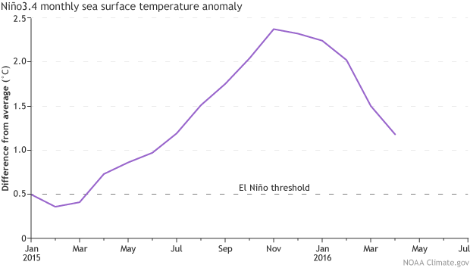
Despite these lingering signs of El Niño, the trend toward neutral conditions is very likely to continue with most computer models predicting El Niño conditions to come to an end during this winter.
Meanwhile the Department of Climate Change and Meteorological Services is closely monitoring weather developments. Should adverse weather be eminent advisories and warnings shall be issued accordingly to keep you safe and well this winter by keeping you informed.

Issued by: Jolamu Nkhokwe
Director of Climate Change and Meteorological Services
Sunday 22nd May 2016
Blantyre

