MINISTRY OF NATURAL RESOURCES, ENERGY AND MINING
Department of Climate Change and Meteorological Services

STATEMENT ON WEATHER UPDATE AS FROM 30 MAY TO 6 JUNE 2016
As from Monday 30th May up to Saturday 4th June chilly weather conditions associated with patches of rain drizzle over highlands (Chiperoni) and fog in low lying areas and some high ground punctuated with partly cloudy conditions during day time with light to moderate Mwera winds over lake are expected over the country because of the dominance of an influx of fairly Cool and moist south easterly air mass over the country.

As on Sunday 5th June windy conditions are expected because of the atmospheric pressure build up over the Republic of South Africa due to an incoming high pressure area moving from the Atlantic Ocean into the Indian Ocean.

Chilly weather conditions associated with patches of rain drizzle over highlands (Chiperoni), fog in low lying areas and some high ground with an outburst of fresh to strong Mwera wind over Lake Malawi are therefore expected from Monday 6th June due to an influx of relatively cool and moist airflow from the south east brought into Malawi by a huge high pressure area located off the south east coast of the Republic of South Africa.

Otherwise Cold nights and locally very cold mornings are expected daily over the country during the whole period.
As the temperature is the result of the amount of heat energy we receive from the sun which always shines towards the equator, the type of weather we get during any seasons is controlled by the temperature we receive from the sun.
The difference in temperature between the summer and the winter is due to the slant of the Earth’s alignment. During the winter, the sun's rays hit the Earth at a shallow angle because planet earth tips over to one side by about 23.5 degrees. This slanting of the earth affects the way that the sun shines us, where the sun rays are more spread out, coming in at a shallow angle with more of the atmosphere to filter through minimizing the amount of heat energy that hits the earth. As the temperature is the result of the amount of heat energy we receive from the sun which always shines towards the equator, during day time during winter, the sun is lower in the sky and the heating during day times get shorter because the southern hemisphere of the earth is tilted away from the sun. The long nights and short days provide fewer hours of sun during day time resulting in less warming of the atmosphere in winter than in the summer.
Climatologically winter season in Malawi started on 1st May 2016. During the winter season the frequent passages of huge high pressure areas from the Atlantic Ocean into the Indian Ocean through the south east coast of the Republic South Africa (RSA) bring into Malawi relatively cool and moist airflow from the south east associated with frequent outbreaks of rain drizzle over highlands locally known as Chiperoni weather is experienced over the country with fog patches in low lying areas and some high ground. Occasional outburst of Mwera wind is also experienced over Lake Malawi.
As temperatures drop during this winter, the general public is advised to eat well, in addition to wearing layers of lightweight clothing, gloves, scarfs and a hat to stay warm and help prevent losing your body heat. Make sure pets have enough shelter to keep them warm. Space heaters should be placed on a level hard surface and away from any flammable items such as paper, clothing, bedding, curtains or rugs. Make sure space heaters are turned off and fireplace embers are out before leaving the room or going to bed. If you are using a fireplace, use a glass or metal fire screen large enough to catch sparks and rolling logs. Never use a stove or oven to heat your home. Install smoke alarms on every level of your home, inside bedrooms and outside sleeping areas. Watch for warning symptoms of hypothermia of just feeling miserably cold, including confusion, dizziness, exhaustion and severe shivering where the temperature of the body core falls from what it should be at 37°C to 35°C or less. Cold air is a particular trigger of asthma attacks. This can be avoided by not breathing in cold air so quickly by staying indoors or by wearing a scarf over the mouth. Breathe through the nose rather than the mouth to warm up any breathed air. Watch for frostbite symptoms which include numbness or waxy feeling skin where ice crystals form inside body cells killing them in the process which can lead to deep frostbite resulting in loss of fingers, toes and even parts of limbs. If you suffer from frostbite, move to warmer place and seek medical attention immediately. The immune system is depressed to some degree by cold weather which particularly affects the upper respiratory tract of the body when cold air is breathed in giving more opportunity to viruses that cause sore throat, cold and flu to reproduce. You are therefore more likely to catch a cold when temperatures are low. Maintain regular contact with vulnerable people and neighbours you know to be at risk in cold weather. Ensure these have access to warm food /drinks and are managing to heat their home adequately. Take the weather into account when planning your activity over the following days. Avoid exposing yourself to cold outdoor conditions if you are at a higher risk of cold-related illness or falls. Those plying over Lake Malawi should excise extra caution to avoid loss of life and property due to the Mwera winds. The public is also advised to pay attention for daily weather forecasts updates on local television and radios in the country.

El Niño update in the month of May 2016 shows that Sea surface temperatures (SSTs) in the Nino region have been cooling steadily since they peaked at 2.4°C above average back in November 2015. In the month of April 2016 cooling has accelerated to 1.2°C above average in the Eastern Central Tropical Pacific Ocean which is still well above the El Niño threshold of 0.5°C above average (see Figure below). This means the atmosphere in the world is still responding to this weakening El Nino phenomenon.

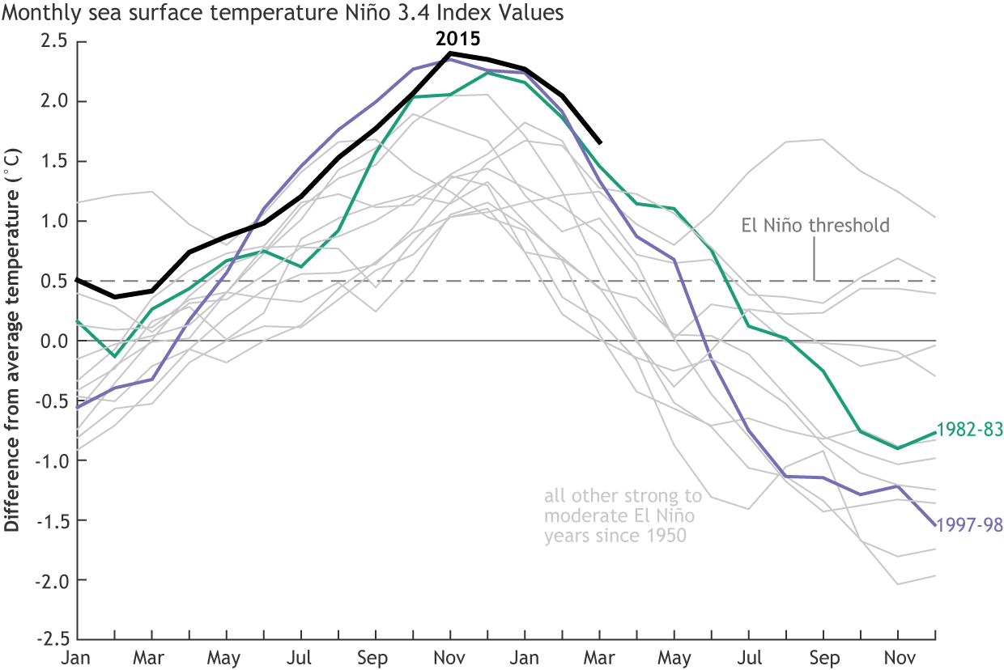
Despite these lingering signs of El Niño, the trend toward neutral conditions is very likely to continue with most computer models predicting El Niño conditions to come to an end during this winter. It will soon be time to bid good-bye to the strong El Niño of 2015-2016 after more than a year of El Niño conditions. Forecasters anticipate that sea surface temperatures in the Niño region of Pacific Ocean will drop below the El Niño threshold of 0.5°C above the long-term average during this June. This means El Niño is still hanging around and affecting our weather.
The difference between weather and climate has to always be emphasised. Weather is what you get while Climate is what you expect. Weather is the condition of the atmosphere over a brief period of time. For example, we speak of today’s weather or the weather this week. Climate represents the composite of day-to-day weather over a longer period of time.
A climatologist attempts to discover and explain the impacts of climate so that society can plan its activities, design its buildings and infrastructure, and anticipate the effects of adverse conditions. Although climate is not weather, it is defined by the same terms, such as temperature, precipitation, wind, and solar radiation. Houses have to be designed based on the climate where we live. Farmers have to make plans based on the length of climate of the growing season. At the same time utility companies base power supplies on what they expect to be the maximum need for heating in the winter climate and the maximum need for cooling in the summer climate.
Additionally, climate is usually defined by what is expected or “normal” weather, which climatologists traditionally interpret as the 30-year average weather.
The 2015/16 El Nino contributed to the planet's warmest year since at least the 1880s. The cycles occur every two or three years on average and help regulate the temperature of the Earth as the equatorial Pacific absorbs the heat of the sun during the El Nino and then releases it into the atmosphere. Historically, Peruvian fisherman centuries ago were first to notice the Pacific Ocean would often warm in November or December. They called the phenomenon El Nino, after the Christ child. Modern researchers came to realize its importance to global weather in the 1960s, when they recognized the link between El Nino and corresponding atmospheric changes. They tweaked the name to El Nino with its opposite as La Nina which was named about two decades later. While the world waits to see if a La Nina will develop, there is always a chance it could fizzle because prediction models perform better around June and July than they are now.
Meanwhile the Department of Climate Change and Meteorological Services is closely monitoring weather developments. Should adverse weather be eminent advisories and warnings shall be issued accordingly to keep you safe and well this winter by keeping you informed.

Issued by: Jolamu Nkhokwe
Director of Climate Change and Meteorological Services
Sunday 30th May 2016
Blantyre

