MINISTRY OF NATURAL RESOURCES, ENERGY AND MINING
Department of Climate Change and Meteorological Services

STATEMENT ON WEATHER UPDATE AS FROM 5 TO 11 JUNE 2016

As from Sunday 5th June to Thursday 9th June 2016, chilly weather conditions associated with patches of rain drizzle over highlands (Chiperoni), fog in low lying areas and an outburst of fresh to strong Mwera wind over Lake Malawi are expected due to an influx of relatively cool and moist airflow pumped from the south east into the country by a huge high atmospheric pressure area located off the south east coast of the Republic of South Africa moving from the Atlantic Ocean into the Indian Ocean..

As from 10th June to 11th June there will be a gradual pick up in day time temperatures with sunny intervals over the country.

However, as from Sunday 12th June another wave of Chiperoni weather over highlands and an outburst of Mwera wind over Lake Malawi are likely to set in.

Otherwise Cold nights and locally very cold mornings are expected daily over the country during the whole period.
The temperature is the result of the amount of heat energy we receive from the sun which always shines towards the earth. As Malawi is experiencing winter weather season that started on 1st May 2016 when nights are longer and days are shorter as the sun's rays hit the country at a shallow angle resulting in more of the atmosphere to filter through thereby minimizing the amount of heat energy reaching the country as planet earth is tipping over to one side by about 23.5 degrees resulting in fewer hours of heating and less warming of the atmosphere during day times as Malawi and the southern hemisphere is tilted away from the sun.
During winter season in Malawi there is frequent passages of huge high atmospheric pressure areas from the Atlantic Ocean moves into the Indian Ocean through the south east coast of the Republic South Africa (RSA) pumping into Malawi relatively cool and moist airflow from the south east associated with frequent outbreaks of rain drizzle over highlands locally known as Chiperoni weather with fog patches in low lying areas and some high ground associated with occasional outburst of Mwera wind over Lake Malawi.
Due to a drop in temperatures, the general public is advised to eat well, in addition to wearing layers of lightweight clothing, gloves, scarfs and a hat to stay warm and help prevent losing your body heat. Space heaters should be placed on a level hard surface and away from any flammable items such as paper, clothing, bedding, curtains or rugs. Space heaters should be turned off and fireplace embers should be put out before leaving rooms or going to bed. A glass or metal fire screen should be used on a fireplace, large enough to catch sparks and rolling logs. Never use a stove or oven to heat your home. Install smoke alarms in all rooms and outside sleeping areas. Pets should have enough shelter to keep them warm. Watch for symptoms of hypothermia of just feeling miserably cold, including confusion, dizziness, exhaustion and severe shivering where the temperature of the body core falls from what it should be at 37°C to 35°C or less. Cold air is a particular trigger of asthma attacks. Asthmatic persons should avoid not breathing in cold air so quickly by staying indoors or by wearing a scarf over the mouth. Breathe through the nose rather than the mouth to warm up any breathed air. Watch for frostbite symptoms which include numbness or waxy feeling skin where ice crystals form inside body cells killing them in the process which can lead to deep frostbite resulting in loss of fingers, toes and even parts of limbs. Once affected by frostbite, move to warmer place and seek medical attention immediately. You are more likely to catch a cold as temperatures drop because the immune system is depressed to some degree by cold weather which particularly affects the upper respiratory tract of the body when cold air is breathed in giving more opportunity to viruses that cause sore throat, cold and flu to reproduce. Maintain regular contact with vulnerable people and neighbours you know to be at risk in cold weather and ensure that they have access to warm food or drinks and their homes are adequately heated. Avoid outdoor cold conditions if you are at a higher risk of cold-related illness.
Those plying over Lake Malawi should excise extra caution to avoid loss of life and property due to the Mwera winds. The public is also advised to pay attention for daily weather forecasts updates on local television and radios in the country. The weather should be taken into account when planning daily activity.
The June solstice is the Summer Solstice in the Northern Hemisphere and the Winter Solstice the Southern Hemisphere. 'Solstice' means 'sun-stopping', because the point where the sun appears to rise and set, stops and reverses direction after this day. The date varies between June 20 and June 22, depending on the year, and which time zone you are in. June Solstice in Blantyre is on Tuesday, 21 June 2016. A solstice happens when the sun's zenith is at its furthest point from the equator. On the June solstice, it reaches its northernmost point and the Earth’s North Pole tilts directly towards the sun, at about 23.4 degrees. It's also known as the northern solstice because it occurs when the sun is directly over the Tropic of Cancer in the Northern Hemisphere. The point on the horizon where the sun appears to rise and set, stops and reverses direction after this day. On the solstice, the sun does not rise precisely in the east, but rises to the north of east and sets to the north of west, meaning it's visible in the sky for a longer period of time.
Although the June solstice marks the first day of astronomical summer, it's more common to use meteorological definitions of seasons, making the solstice midsummer or midwinter.
Meanwhile, El Niño update in the month of May 2016 shows that Sea surface temperatures (SSTs) in the Nino region have been cooling steadily since they peaked at 2.4°C above average back in November 2015. In the month of April 2016 cooling has accelerated to 1.2°C above average in the Eastern Central Tropical Pacific Ocean which is still well above the El Niño threshold of 0.5°C above average (see Figure below). This means the atmosphere in the world is still responding to this weakening El Nino phenomenon.

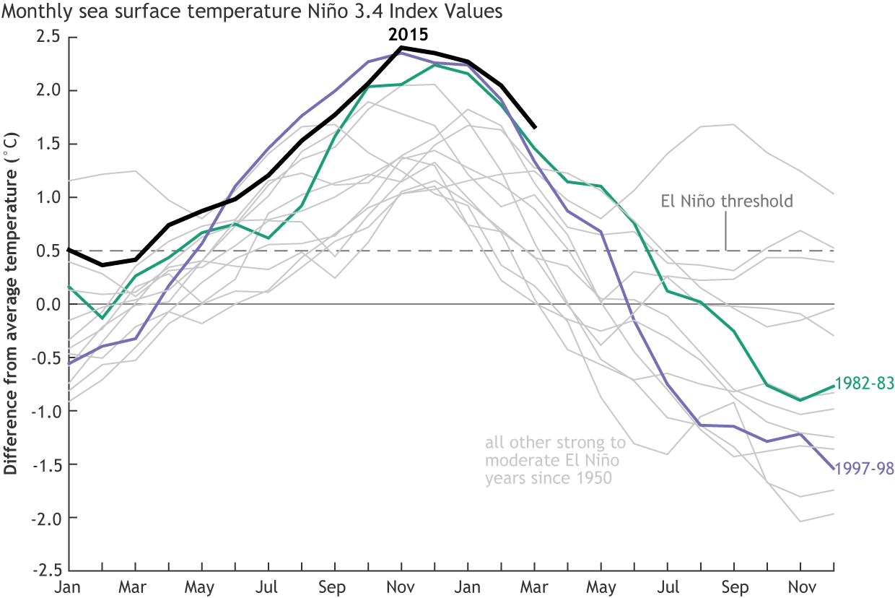
Despite these lingering signs of El Niño, the trend toward neutral conditions is very likely to continue with most computer models predicting El Niño conditions to come to an end during this winter. It will soon be time to bid good-bye to the strong El Niño of 2015-2016 after more than a year of El Niño conditions. Forecasters anticipate that sea surface temperatures in the Niño region of Pacific Ocean will drop below the El Niño threshold of 0.5°C above the long-term average during this June. One of the strongest El Niño’s on record is shrinking and becoming shallower, meaning it’s most likely on its way out. With the Pacific Ocean cooling off after a near-record El Niño, signs are pointing to an impending La Niña - the flip-side of El Niño. Ever since El Niño 2015 reached its peak in November, forecasters have been anticipating its eventual dissipation, and there has been keen interest in exactly how that will proceed. As of the mid-March analysis by forecasters, the odds of seeing a La Nina or having some mix of El Niño and neutral conditions developing by the end of the year were still fairly even. It has only been at the latest forecast update that the chances of a La Niña developing jumped to over 70 per cent based on what they are seeing in computer model runs. La Niña conditions are where sea surface temperatures of -0.5ºC or lower on the scale in the Nino region of the Pacific Ocean are recorded.
As it stands now, it's too early to tell exactly how strong of a La Niña we could see, or how long it could last, but based on the past, the pattern could develop along a few different paths. It could swing sharply into a record-breaking La Niña. This is what happened in 1988-1989, after the strong, double-peaked El Niño in 1986-1987. It may produce another multi-year La Niña, like there was following the sharp, very strong El Niños in 1982 and 1997. It could also result in a combination of the two - a record or near-record event in both strength and duration. The most likely outcome, based on the current look, is a moderate to strong La Niña. Despite the uncertainties related to the timing of the arrival of La Niña, we will also have to keep an eye on the evolution of sea surface temperatures over the oceans because prediction models perform better around June and July than they are now. This means El Niño is still hanging around and affecting our weather. However, the strongest La Niñas do not necessarily follow the strongest El Niños or vice versa.
The difference between weather and climate has to always be emphasised. Weather is what you get while Climate is what you expect. Weather is the condition of the atmosphere over a brief period of time. For example, we speak of today’s weather or the weather this week. Climate represents the composite of day-to-day weather over a longer period of time.
A climatologist attempts to discover and explain the impacts of climate so that society can plan its activities, design its buildings and infrastructure, and anticipate the effects of adverse conditions. Although climate is not weather, it is defined by the same terms, such as temperature, precipitation, wind, and solar radiation. Houses have to be designed based on the climate where we live. Farmers have to make plans based on the length of climate of the growing season. At the same time utility companies base power supplies on what they expect to be the maximum need for heating in the winter climate and the maximum need for cooling in the summer climate. Additionally, climate is usually defined by what is expected or “normal” weather, which climatologists traditionally interpret as the 30-year average weather.
While the 2015/16 El Nino contributed to the planet's warmest year since at least the 1880s, the cycles occur every two or three years on average and help regulate the temperature of the Earth as the equatorial Pacific absorbs the heat of the sun during the El Nino and then releases it into the atmosphere. Historically, Peruvian fisherman centuries ago were first to notice the Pacific Ocean would often warm in November or December and called this El Nino, after the Christ child. Modern researchers came to realize its importance to global weather in the 1960s, when they recognized the link between El Nino and corresponding atmospheric changes. They named its opposite as La Nina which was named about two decades later.
Meanwhile the Department of Climate Change and Meteorological Services is closely monitoring weather developments. Should adverse weather be eminent advisories and warnings shall be issued accordingly to keep you safe and well this winter by keeping you informed.
Issued by: Jolamu Nkhokwe
Director of Climate Change and Meteorological Services
Sunday 5th June 2016
Blantyre

