 | The Gambia Meteorological Services  Department of Water Resources  7 Marina Parade

Monthly Climate Bulletin
No.10 January-February-March 2016

1.0 Station history of The Gambia Meteorological Network & rainfall stations

The Gambia Meteorological service used to operate fifteen (15) Network stations covering all the regions in the country, but these was reduced to ten (10) in 2008. As of now, the department operates 10 synoptic weather stations and 25 rainfall statons.

2.0 Part I : Temperature in degrees Celsius (⁰C) for January-February-March 2016

Station _codes |  |  | MeanT-2016 | Normal  1981-2010 | MeanTmax-  2016 | Normal  Tmax | MeanTmin-2016 | Normal  Tmin | AbTmax-2016 | Normal  AbTmax | AbTmin-2016 | Normal  AbTmin
WMO | National | Name
61711 | 15003000 | Banjul Halfdie/Marina | 24.7 | 28.0 | 32.4 | 32.4 | 17.1 | 22.0 | 37.6 | 32.8 | 19.6 | 18.6
61731 | 15001200 | Basse | 25.6 | 27.1 | 36.5 | 37.4 | 14.7 | 24.9 | 39.7 | 39.6 | 18.9 | 15.0
61733 | 15006600 | Fatoto disp./met. | 27.8 | 27.2 | 38.8 | 37.6 | 16.8 | 24.3 | 41.4 | 40.0 | 20.4 | 15.4
61721 | 15003900 | Georgetown | 27.0 | 27.1 | 37.5 | 37.1 | 16.4 | 23.7 | 40.7 | 39.4 | 19.9 | 15.3
61707 | 15004900 | Jenoi | 26.5 | 26.8 | 37.2 | 36.8 | 15.8 | 22.4 | 40.5 | 38.8 | 20.8 | 14.4
61717 | 15000600 | Kaur | 27.8 | 27.6 | 37.1 | 36.8 | 18.5 | 23.0 | 41.0 | 38.9 | 23.0 | 17.2
61712 | 15003300 | Kerewan | 27.4 | 27.3 | 37.4 | 36.0 | 17.2 | 21.6 | 40.9 | 38.6 | 19.6 | 14.3
61722 | 15006200 | Sapu | 27.1 | 26.6 | 36.5 | 36.6 | 17.7 | 23.4 | 40.0 | 38.9 | 22.6 | 14.7
61705 | 15005900 | Sibanor | 25.9 | 26.6 | 38.2 | 36.0 | 13.2 | 21.7 | 42.3 | 38.1 | 15.9 | 16.1
61701 | 15005400 | Yundum Airport | 26.9 | 26.7 | 35.7 | 33.8 | 18.2 | 21.5 | 39.7 | 34.7 | 20.4 | 16.9

2.1: Temperature Variation

The graph in figure 2.1 below shows mean temperature variation over the country. The values of both the Maximum and the Absolute maximum temperatures range between 32.4 to 42.3 ⁰C, whilst the values of the Minimum and the Absolute minimum temperature ranges between 13.2 to 23.0 ⁰C. However, the highest temperature of 42.3⁰C and lowest temperature values of 13.2 ⁰C are observed at Sibanor.

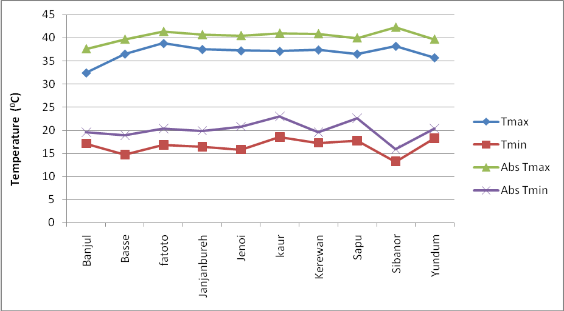

Figure 1: Temperature Variation (⁰C) for January-February-March 2016

3.0 Part II: Relative Humidity in percentage (%) and Wind in metres per second (m/s) for
January-February-March 2016.
Station Codes |  |  | Relative Humidity (%) |  |  |  | Windspeed (m/s)_2016
WMO | National | Name | MeanRH_2016 | 1981-2010 | MaxRH_2016 | MinRH_2016 | Mean | Highest
61711 | 15003000 | Banjul Halfdie/Marina | 46 | 63 | 83 | 18 | 6.0 | 12
61731 | 15001200 | Basse | 37 | 64 | 81 | 8 | 2.4 | 16
61733 | 15006600 | Fatoto disp./met. | 28 | 57 | 87 | 7 | 6.2 | 16
61721 | 15003900 | Georgetown | 33 | 60 | 87 | 8 | 3.6 | 14
61707 | 15004900 | Jenoi | 34 | 57 | 87 | 10 | 4.4 | 12
61717 | 15000600 | Kaur | 23 | 52 | 75 | 6 | 7.0 | 18
61712 | 15003300 | Kerewan | 34 | 59 | 76 | 10 | 7.3 | 12
61722 | 15006200 | Sapu | 27 | 58 | 84 | 15 | 7.8 | 17
61705 | 15005900 | Sibanor | 42 | 63 | 95 | 19 | 3.5 | 15
61701 | 15005400 | Yundum Airport | 43 | 70 | 89 | 11 | 6.0 | 18

4.0 Part III: Sunshine (hours) and Evaporation (mm) for January-February-March 2016.

Station_codes |  |  | Sunshine 2016 |  |  |  | Evaporation Class A (mm) 2016
WMO | National | Name | Total | Normal_1981-2010 | Max | Min | Total | Mean
61711 | 15003000 | Banjul Halfdie/Marina | * | * | * | * | * | *
61731 | 15001200 | Basse | 248.1 | 192.2 | 10.8 | 2.0 | 175.2 | 5.9
61733 | 16006600 | Fatoto disp/met. | 228.1 | 86.7 | 10.9 | 4.2 | 199.5 | 6.6
61721 | 15003900 | Georgetown | 244.6 | 147.1 | 10.9 | 0.5 | 176.7 | 5.8
61707 | 15004900 | Jenoi | 203.7 | 181.5 | 10.7 | 1.3 | 210.6 | 6.9
61717 | 15000600 | Kaur | 293.0 | 99.7 | 11.2 | 2.5 | 287.0 | 9.5
61712 | 15003300 | Kerewan | 206.7 | 201.8 | 10.6 | 1.0 | * | *
61722 | 16006200 | Sapu | 93.5 | 125.9 | 10.8 | 2.4 | 211.0 | 6.9
61705 | 15005900 | Sibanor | 226.5 | 116.5 | 10.7 | 1.2 | 148.9 | 4.9
61701 | 15005400 | Yundum Airport | 258.6 | 218.5 | 10.5 | 2.1 | 168.4 | 5.6

5.0 Part IV: Climate Report explanations

PREFACE
Selected climatological data of general importance from weather stations in the Gambia has been compiled in this report. The values have been checked. Blank spaces indicate either missing or delayed records. If data are missing one or several days for one station within the selected period, this station are marked with an asterix (*). Observed values (OBS) and the normals (NORM) of these data values from the long period averages are given for the following elements :
- Average air temperature
- Rainfall
- Relative Humidity
- Sunshine
- Interpolated map for rainfall is included.

EXPLANATION OF TABLES

- Rainfall (mm) amount is measured every six hours in a standard rain gauge 80cm above ground level. The Total rainfall amount for any given day is the cumulative or accumulated six hourly rainfall amounts. A Rainy day is defined as a day with a total rainfall amount equal or more than 1mm.
- Air Temperature (°C) observations are made from thermometers exposed in Stevenson Screens, 1.25 metres above the ground. The Maximum and Minimum Temperature (°C) observed/ obtained, indicates the highest and lowest temperatures during the specified period.
- Relative Humidity is derived from the readings of the dry and wet bulb thermometers and expressed in Percentage (%).
- Sunshine Duration is measured using a Campbell-Stokes Tropical Sunshine Recorder and is recorded in hours.
- Actual Evaporation is determined from a Class A Pan and measured in millimetres (mm).
- Wind speed per day is read from a Cup Counter Anemometer mounted 10 metres above the ground and read in knots. It can also be converted to metres per second (m/s) or kilometer per hour (km/h).
Abbreviations :
- MeanT : Mean Temperature
- Mean Tmax : Mean Maximum Temperature
- Mean Tmin : Mean Minimum Temperature
- AbTmax : Absolute Maximum Temperature
- AbTmin : Absolute Minimum Temperature

Published by: Climate Unit
Department of Water Resources
7 Marina Parade
Banjul, The Gambia
Telephone: 00 (220) 422-7631/4222-872/422-4122
Fax: 00 (220) 422-5009
http://www.mofwrnam.gov.gm
E-mail: info@mofwrnam.gov.gm; infoclimate@gmail.com

