EARLY WARNING BULLETIN FOR FOOD SECURITY

No. 2015/18 IN THE GAMBIA Period: October 21-31, 2015

 Government of The Gambia | Produced and Published by The Gambia National Multidisciplinary Working Group  Focal Point: Department of Water Resources  TEL: (+220) 4227631 / 4224122 / 8905229 - FAX: (+220) 422 50 09  E-MAIL: dwr@mofwrnam.gov.gm / WEB: www.mofwrnam.gov.gm | 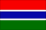

1.0 METEOROLOGICAL SITUATION

1.1 SYNOPTIC SITUATION
The surface position of the ITD embarked on its southward retreat, oscillating over northern Senegal, southern Mali and then slanting over northwest Niger. The southward retreat of the ITD is a signature of the departure of the rainy season in the Sahel region though the motion is very slow due to warming of Sea Surface Temperatures (SSTs) in the North Atlantic Ocean.

Dry and stable atmosphere prevailed to the north of the ITD with patches of dust haze observed over some part of North Africa. To the South of the ITD, convective activities affected western part of the Sahel region and Gulf of Guinea States resulting to rains and thunderstorms, occasionally associated with strong winds over the Senegal, Gambia and Guinea Bissau.

1.2 WEATHER SUMMARY FOR THE GAMBIA
Variably cloudy and humid atmosphere prevailed with rain and thunderstorms occasionally associated with strong winds or heavy downpour over much of Sahel states.

2.0 AGROMETEOROLOGICAL SITUATION

2.1 RAINFALL SITUATION

Recorded rainfall figures in this dekad showed some variations across the country. In the Western Third, dekadal totals were highest over Yundum 40.3mm to 7.7mm over Banjul. In the Middle Third dekadal totals varied between 59.7mm highest over Jenoi to 25.4mm over Janjanbureh. In the Eastern Third Basse recorded trace, while Fatoto recorded a decadal total of 5.1mm, (Figure1a).

Seasonal rainfall amounts recorded as of 31st October indicate high seasonal variations in recorded rainfall amounts over the country. In the Eastern Third seasonal totals were 1017.2mm and 900.6mm over Basse and Fatoto respectively. In the Middle Third, Sapu recorded the highest of 1255.2mm, to 593.3mm over Kaur.In the Western Third, Yundum Airport recorded 1358.4mm highest Countrywide, Sibanor and Kerewan recorded 1343.1mm and 1232.2mm respectively; whilst Banjul recorded the lowest 803.8mm. (Figure1b).

Figure 1a: Rainfall dekadal totals 21 –31 October 2015.

Figure 1b: Rainfall Seasonal totals from May 1st 2015 – October 31st 2015.

2.2 RAINFALL COMPARISMS AND 2015 RAINY SEASON ANALYSIS

The Country average as of 31st October 2015, stand at 928.0, 45.2% above the country average of last year (31st October 2014, 638.9mm), and 11.2% above the long term mean: 834.4mm).

An overview of the Current State of 2015 Rainy Season in the Gambia
The seasonal rainfall prediction over the Gambia for the 2015 rainy season depicted late Onset, Above Normal quantity and early Cessation. The forecast was in line with the regional consensus forecast presented at the second edition of PRESASS (Regional Climate Outlook Forum for Sudanese-Sahelian States) in West Africa held in Dakar in May 2015.

However, the country had experienced late onset but a significant rainfall downpour in August which extended into much part of September 2015. The record at the end of September 2015 shows an average rainfall quantity has entered into Above Normal category and rains defied early cessation.

Why Gambia has experienced rains Above Normal despite Occurrence of Strong El Nino and why rains extended beyond the season.
The year 2015 is marked with strong El Nino episode, the abnormal warming of Sea Surface Temperatures (SSTs) in the Tropical Equatorial Pacific, Indian and North Atlantic Oceans. Evidences and experiences, coupling with scientific literatures depicted that El Nino years are associated with low rainfall distribution in the Sahel region including the Gambia.
The evolution of the current SSTs shows warming in the Tropical Equatorial Pacific, North Atlantic and Indian Oceans as shown in figure 2.The maps were obtained from the NOAA Climate Prediction Centre, Washington DC.

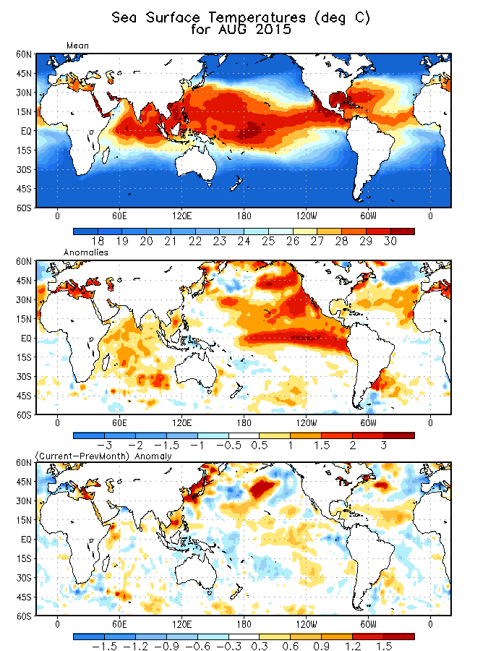
Figure 2:
Warm SSTs over North Atlantic Ocean
Warm SSTs over Indian Ocean
Warm Mediterranean Sea
Warm SSTs over Tropical Equatorial Pacific Ocean

The behaviour of SSTs in the South Atlantic Ocean depicted a cooling trend as shown in figure 3 below.

Figure 3: The cool SSTs in the South Atlantic Ocean

For this rainy season (2015), Gambia has experienced heavy precipitation leading to rainfall average above normal. The higher precipitation is attributed to warming of SSTs over North Atlantic Ocean (figure 1) and cooling over South Atlantic Ocean (figure 2). While the cooling over South Atlantic Ocean facilitates the meridional flow of deep moist south-westerly winds crossing the equator into Guinea Bissau, The Gambia and Senegal, the warming over North Atlantic Ocean serves as source of energy enhancing more convective activities in the region, notably in the month of August which extended into greater part of September. The warming in the North Atlantic Ocean also energized the activeness of African Easterly Waves (AEW) which led to increase in the frequency of squall lines (strong winds associated with heavy rains and thunderstorms) and hence flooding and infrastructural damages affected much parts of the country.

However, it is the same warming in the North Atlantic Ocean that persist into the month of October and continue to enhance high humidity, convection and moisture concentration in the atmosphere resulting to occurrence of rainfall beyond the Rainy Season.

The warming in the Mediterranean Sea also attracted and fast-track the northward motion of the Inter-Tropical Convergence Zone (ITCZ) and encouraged deep moisture build-up over western portion of the Sahel in the month of August facilitates more precipitation in the Gambia and its environments.

It can be therefore concluded that the warming over North Atlantic and cooling over South Atlantic Oceans coupling with the warming over Mediterranean Sea overturn the influence of the current El Nino episode over the countries at the extreme west of the Sahel including the Gambia. Instead of less rain, the region recorded above normal situation.

2.3 Temperature

Average temperatures across the country vary between 28°C in the Middle Third to 31°C in the rest of the country.

2.4 Winds

Winds were light to moderate with maximum speed of 64km/h in the Middle Third.

2.5 Sunshine Duration

Sunshine duration on average in this dekad was above 6hours across the Country.

2.6 Relative Humidity

Average relative humidity across the country is still high above 70% throughout the country.

3.0 Hydrological Situation
N/A

4.0 AGRICULTURAL SITUATION

WEST COAST REGION
N/A

NORTH BANK REGION

Agricultural activity in this region is mainly harvesting of major crops. Harvesting is in progress for early millet, rice, cowpea, and findi. Crops like maize and early maturing type groundnut (Bruccus) have been harvested. Both harvesting and sowing is in progress for water. Nursery preparation is in progress for dry season vegetable gardening. However there were some unidentified pest attacks on the rice fields reported by the farmers, but due to continuous rainfall, the situation was controlled.

LOWER RIVER REGION
Farmers in this region have almost completed harvesting on some major cereals like early millet and maize. Crops like cowpea, water melon, and upland rice is also been harvested. However, the presence of weaver birds and bush pigs is still a problem for farmers.

CENTRAL RIVER REGION NORTH

N/A

CENTRAL RIVER REGION SOUTH

Farmers in this region are engaged in transplanting of rice especially irrigated rice, harvesting of early millet, groundnut, maize, water melon, upland rice and cowpea. Transplanting is in progress in the lowland fields, although due to flooding most seedlings were washed away but farmers are managing with the situation. Due to high water level there is increased Hippo attacks as they can easily intrude from different angles of the fields.

UPPER RIVER REGION

In this region harvesting of major cereals like early millet and maize have been completed, crops like groundnut, cowpea and water melon are being harvested. Late millet sorghum and some rice fields in the swampy areas are at maturity stage. However, due to continuous rains during the season, some crops especially cereals might not perform to expectation.

4.1 COMMODITY PRICES
N/A

4.2 CROP PROTECTION
N/A

4.3 LIVESTOCK

The Livestock situation in the Country remains satisfactory due to the abundance of feed and water. Clinical treatment figures have also climbed down and animals’ health status and productivity have risen owing to the availability of succulent palatable grasses in all pastures and easy access to adequate water. It is also significant to note that the pest load in the grazing areas has declined due to the heavy and continuous down pour of rain. In CRR-N, 51 heads of cattle were treated for suspected cases of multiple diseases, 62 goats, 70 Sheep, 74 horses and 57 donkeys were treated during the third dekad of October.
LRR reported 68 heads of cattle, 57 Sheep, 63 goats, 42 horses, and 39 donkeys were treated. CRR-S, 80 heads of cattle 77 Sheep 56 goats’ 73 horses and 49 donkeys were treated. Clinical treatment figures for NBR, 78 heads of cattle 60 Sheep 53 goats’ 66 horses’ 43 donkeys were treated. WCR 94 heads of cattle 58 Sheep 82 goats 55 horses and 31donkeys were treated.URR 102 heads of cattle 56 Sheep 79 goats’ 67 horses 54 donkeys were treated. It is paramount to note that the escalation in the number of cases in some regions is as a result of exposure to heavily infested pastures. As we get into the cold season, infections are expected to rise due to the warm weather during the day. However, Some of the cases were suspected cases of various diseases and others were conducted on prophylactic bases. The Department of Livestock Services will not relent on its drive to prevent and control animal diseases in the Country.

4.4 FISHERIES
N/A

5.0 NATIONAL DISASTER MANAGEMENT AGENCY (NDMA)
N/A

6.0 NATIONAL ENVIRONMENT AGENCY (NEA)
N/A

Banjul November 2nd 2015
National MWG of The Gambia

Composition of MWG:  Department of Water Resources  Planning Services - Department of Agriculture (DOA)  Communication, Extension & Education Services - DOA  Department of Livestock Services  Plant Protection Services - DOA  National Environment Agency | Direct your comments and questions to:  The Director  Department of Water Resources  7 Marina Parade, Banjul  The Gambia  Tel: (+ 220) 422 76 31 / 422 41 22 / 890 52 29  Email: dwr@mofwrnam.gov.gm

