EARLY WARNING BULLETIN FOR FOOD SECURITY

No. 2017/04 IN THE GAMBIA Period: June 1 – 10, 2017

 Government of The Gambia | Produced and Published by The Gambia National Multidisciplinary Working Group  Focal Point: Department of Water Resources  TEL: (+220) 4227631 / 4224122 / 8905229 - FAX: (+220) 422 50 09  E-MAIL: dwr@mofwrnam.gov.gm  WEB: www.mofwrnam.gov.gm | 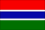

- METEOROLOGICAL SITUATION

1.1 GENERAL SYNOPTIC SITUATION

The mean surface position of the Inter Tropical Discontinuity (ITD), a boundary layer that separates the dry hot Northeasterly from the moist warm Southwesterly winds is continuing on its northward motion, lying across just one degree south (1°S) of western part of the Gambia and one degree north (1°N) of eastern part of the country during the last dekad. Beyond The Gambia, it oscillates over central Senegal, central Mali, southern Niger and then slanting onto Chad.

Dry and stable atmosphere prevailed to the north of the ITD with dust haze observed over northern Mauritania, southern parts of Algeria and Libya. Conversely, places to the south of the ITD were characterized by convective activities leading to rain and thunderstorms over eastern parts of The Gambia and Senegal, Guinea Bissau/Conakry, Sierra Leone, Liberia, Ivory Coast, Burkina Faso, Ghana and Gulf of Guinea States. The occurrences were mainly in the evenings into the nights.

1.2 OUT LOOK FOR THE NEXT DEKAD (11TH – 20TH JUNE 2017)
The atmosphere will be generally warm and humid with development of convective activities that will enhance slight rains and thunderstorms at the beginning of the dekad. Moderate to heavy rains and thunderstorms are expected to affect the entire country from the 18th June 2017 onwards.

2.0 AGROMETEOROLOGICAL SITUATION

2.1 RAINFALL SITUATION

The rainfall situation in this dekad has improved especially in the Eastern Sector. Dekadal rainfall recorded were 21.8mm and 20.0mm over Basse and Fatoto respectively all in the Eastern Sector. Jenoi in the Middle Third recorded 0.2mm while some other stations recorded traces. This rainfall situation means that sowing activities may only be favorable for farmers in the Eastern Third except for those farmers interested in dry land sowing for some cereals.
2.2 Temperature

Average temperatures across the country varied between 29°C over the Western Third and 35.0°C over the Eastern Third. Minimum temperatures were between 19°C over the Western Third and 25°C over the Eastern Third, while extreme maximum temperatures were high through out the country 40°C to 43°C highest in the Eastern sector.

2.3 Winds

Winds were generally light to moderate in speed during this dekad, however a maximum gust of 53km/h was recorded over Basse in the Eastern Third towards the end of the dekad.

2.4 Sunshine Duration

Sunshine duration was on average between 8 hours to 9 hours countrywide, with the exception of Fatoto that recorded 7 hours of sunshine during the dekad, which may be due to increased cloud coverage in that extreme Eastern Third of the country.

2.5 Relative Humidity

Average relative humidity (RH) was above 50% throughout the country except for Kaur in the Middle Third that recorded 47% during the dekad.

- Hydrological Situation

Due to high evapotranspiration, the river Gambia water levels continue to decline especially in the eastern most parts, while the tidal amplitude in western parts widened. The saline front is progressively moving upstream towards its upper limit ( towards Kuntaur) as it has already past Kaur about 200 km from the river mouth at Banjul. This movement is exacerbated by the abstraction of water from the river for irrigation and other uses.

The groundwater levels in boreholes and wells are observed to be gradually declining owing to continued extraction of water for domestic and irrigation purposes.
This situation is expected to intensify until the rains commence, when the river flow will be replenished and the groundwater recharged again.

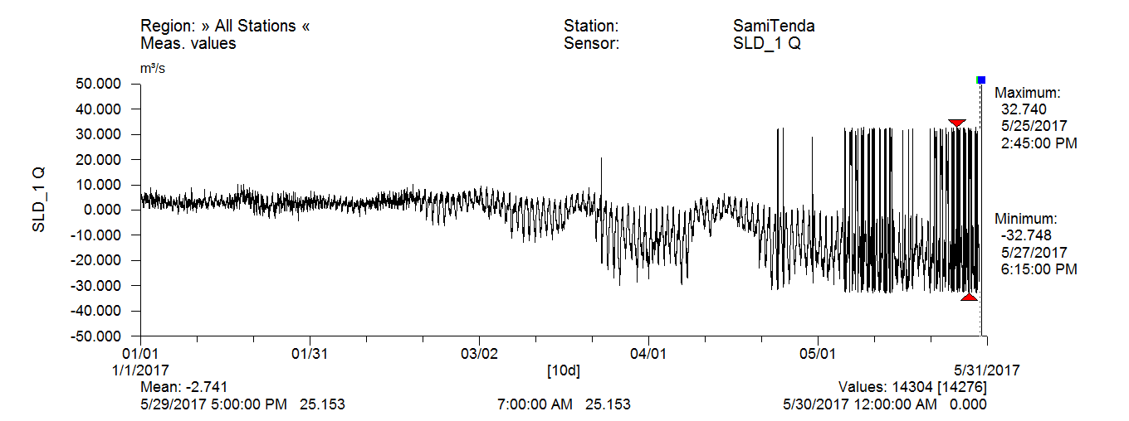

Water levels: Over the past months mean water levels have continued to rise. Except for Ballingho that shows a fluctuating water level, all other stations show increasing trend in water level. Below is a table showing monthly mean water levels of some select stations.

Table 1: Water level monthly means per station
Station | Monthly mean water level (m)
Station | January | February | March | April | May
Ballingho | 0.77 | 0.74 | 0.76 | 0.73 | 0.82
Bansang | 2.09 | 2.07 | 2.11 | 2.17 | 2.28
Kaur | 1.82 | 1.82 | 1.87 | 1.92 | 2.07
Kuntaur | 1.21 | 1.20 | 1.25 | 1.31 | 1.42
Sami-Tenda | 1.04 | 1.07 | 1.26 | 1.35 | 1.53

4.0 AGRICULTURAL SITUATION

The main agricultural activities during this dekad varied per region. Seeds acquisition and Land preparation continues to dominate farmer activities in most regions (clearing, burning, ploughing etc). In the Central River Region North some Rice fields are at booting stage while others are at maturity. Nursery preparation is also ongoing in the lowland fields in this region. In North Bank region some farmers are engaged on sowing of hungry rice (Findi) sowing whereas vegetable gardening is still in progress for farmers in West coast region.

4.1 Crop Protection

NO | PEST | STATUS | DISTRIBUTION | CONTROL
1 | Spiralling Whitefly (SWF) (Aleurodicus disperses) is a small, polyphagous moth-like insect 1 – 2 mm in size that sucks plant sap producing black sooty on the plant and infecting it with viral, bacterial and fungal diseases. Infested plants are stunted and unproductive resulting in death of the plant. The magnitude of crop loss and destruction to landscape and ornamental plants as a result of whitefly infestation is of great economic importance | The pest is found in the Gambia. It is an Alien Invasive Species (AIS) During surveillance, the following pest species were also discovered | It is mainly found in the Urban/Coastal areas of West Coast Region as well as North Bank Region but could spread rapidly to other areas as a result of human activity | Thanks to the intervention of Government of the Gambia with assistance from FAO in the form of a TCP. There are a range of activities going on to control the pest i.e. surveillance, training on Integrated Pest Management and Bio-control
 | Mango mealy bugs (Drosicha mangiferae) | Allien Invasive Specie | Country wide | Studies are underway to come up with the most effective control recommendations
 | Papaya mealy bugs (Paracoccus marginatus) | Allien Invasive Specie | Country wide | Studies are underway to come up with the most effective control recommendations
 | Citrus scale (Unaspis citri) | Allien Invasive Specie | Country wide | Studies are underway to come up with the most effective control recommendations

4.2 Livestock

The Livestock situation in the Country is not impressive as greater part of the grazing fields have been cleared by farmers in preparation for the rainy season. This often results to the indiscriminate burning of bushes that depraved Livestock access to adequate feeds. This exercise is likely to increase the number of clinical cases due to the warm weather which is conducive for some disease vectors. In view of that, clinical treatments figures are likely to rise. The following clinical cases were seen during the Month of June 2017. CRRS 97 heads of cattle, 138 Sheep 202 goats, 9 donkeys and 38 horses. In CRRN 117 heads of cattle 123 sheep 137 goats, 41 donkeys and 37 horses. LRR 82 heads of cattle, 164 Sheep, 206 goats, 31 donkeys and 17 horses. NBR, 142 cattle, 115 Sheep, 183 goats, 34 donkeys and 19 horses.URR 209 heads of cattle, 146 Sheep, 152 goats 67 donkeys and 43 horses. WCR 271 heads of cattle 128 Sheep 245 goats 15 donkeys and 51 horses.
The Department will not be found wanting in its fight against the destructive effects of animal diseases in the Country.

5.0 Market Situation

N/A

Banjul , June 11 2017
National MWG of The Gambia

Composition of MWG:  Department of Water Resources  Planning Services - Department of Agriculture  Department of Livestock Services  Plant Protection Services - DOA  National Environment Agency | Direct your comments and questions to:  The Director  Department of Water Resources  7 Marina Parade, Banjul  The Gambia  Tel: (+ 220) 422 76 31 / 422 41 22 / 890 52 29  Email: dwr@mofwrnam.gov.gm

