EARLY WARNING BULLETIN FOR FOOD SECURITY

No. 2016/09 IN THE GAMBIA Period: July 21-31, 2016

 Government of The Gambia | Produced and Published by The Gambia National Multidisciplinary Working Group  Focal Point: Department of Water Resources  TEL: (+220) 4227631 / 4224122 / 8905229 - FAX: (+220) 422 50 09  E-MAIL: dwr@mofwrnam.gov.gm / WEB: www.mofwrnam.gov.gm | 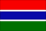

1.0 METEOROLOGICAL SITUATION

1.1. SYNOPTIC SITUATION:

The surface position of the ITD during this dekad oscillated slightly over to central Mauritania, stretching to northern Mali and sloping to central Niamey and onto Chad. Convective cloud developing leading to rains and scattered thunderstorms over The Gambia, Senegal, Burkina Faso, Benin, Guinea Conakry and Ivory Coast were experienced. However, to north of the ITD, dust hazes were reported over northern Mauritania and southern Algeria.

1.2. WEATHER SUMMARY FOR THE GAMBIA
Moderate to heavy rains accompanied with humid atmosphere prevailed over the country during the dekad.

1.3. OUTLOOK FOR THE NEXT DEKAD (1st_10th August 2016)

Variably cloudy to cloudy, warm and humid conditions with rain and thunderstorms are expected over the Country during the period.

2.0 AGROMETEOROLOGICAL SITUATION

2.1 RAINFALL SITUATION

The rainfall situation in this dekad showed significant improvements over the entire country. In the Western Third, Banjul recorded the highest dekadal amount of 147.8mm. In the Middle Third, Jenoi recorded the highest dekadal total of 263.6mm, In the Eastern Third; Basse recorded the highest dekadal total of 129.0mm (figure 1a).

Figure 1a: Rainfall dekadal totals 21ST –31ST July 2016.

Seasonal rainfall totals showed an increased in rainfall quantities throughout the country with the eastern part of the country recording cumulative seasonal totals of 291.0mm and 146.4mm over Basse and Fatoto respectively. Jenoi in the Middle Third, recorded the highest seasonal total in the country so far with 383.2mm, while in the Western Third, Banjul recorded highest amount of 295.7mm. However, the lowest seasonal rainfall total recorded countrywide so far is over Sere Kunda (96.1mm) figure1b below.

Figure 1b: Rainfall Seasonal totals from May 1st 2016– July 31st 2016.

In comparisons, the country average as at 31st July 2016 stood at 277.1mm, which is 171% above last year’s amount (102.3mm) and 4% below the long term mean (30 year period) of (289.9mm).

The rainfall comparisons for this year and that of last year and the long term mean is further illustrated in the figure below
Figure 2: Rainfall comparisons for individual stations.
Legend:
SUM D July 3 2016: Rainfall totals for the third dekad of July 2016
SUM S July 3 2016: Rainfall totals for this year’s rainy season as at July 31st 20116
SUM S July 3 2015: Rainfall totals for last year’s rainy season as at July 31st 20115
Normal 81_10: Country Average for 1981_2010 period as at as at July 31st.

Table1: Daily highest rainfall figures per Station during the dekad (21st – 31st July 2016)

STATION | RAINFALL (Millimeters) | DATE RECORDED
Yundum Airport | 42.1 | 25/07/2016
Sibanor | 36.3 | 23/03/2016
Jenoi | 112.5, 91.9 | 24/07/2016/ 30/07/2016
Banjul | 50.1 | 25/07/2016
Kerewan | 41.0 | 25/07/2016
Kaur | 85.5, 81.5 | 24/07/2016/ 30/07/2026
Janjanbureh | 9.6 | 22/07/2016
Sapu | 105.5 | 23/07/2016
Basse | 83.8 | 23/07/2016
Fatoto | 18.1 | 21/07/2016

2.3 Temperature

Average temperatures across the country varied between 28ºC and 30ºC. Minimum temperature reached 24°C over Banjul, whilst maximum temperature reached 35°C over Jenoi.

2.3 Winds

Winds were generally light, moderate to strong with maximum gusts of 27km/h over the entire country.

2.4 Sunshine Duration

Due to increase cloud cover during the dekad, Sunshine duration has decreased between 4 to 5 hours.

2.5 Relative Humidity

Average relative humidity during this dekad was above 75% countrywide indicating high moisture content during this period.

3.0 Hydrological Situation

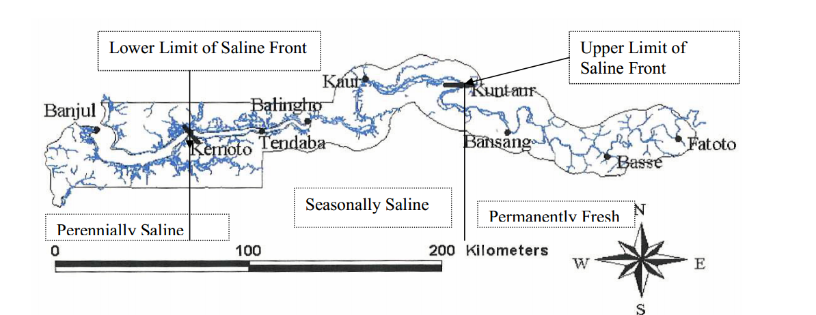
Figure 3: Hydrological stations and the saline front limits

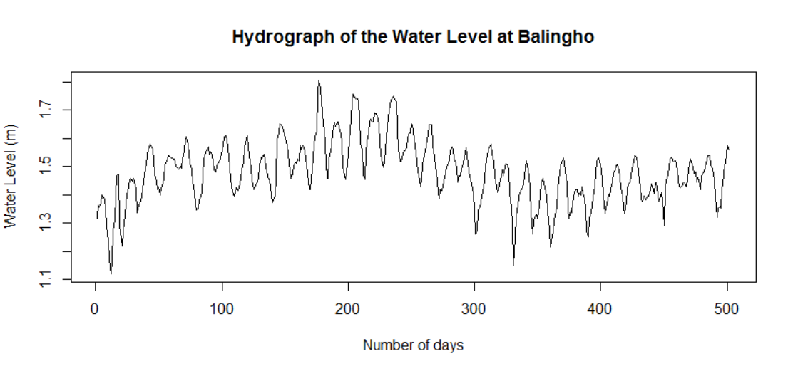
Figure 4: Hydrograph of the water level at Balingo.

The graph shows the daily maximum water level from 3rd February, 2015 to 23rd July, 2016.The flow or water level for the last three months shows a normal trend. Due to the flat nature of the flood plain around this station, the flood graph could not be too high.

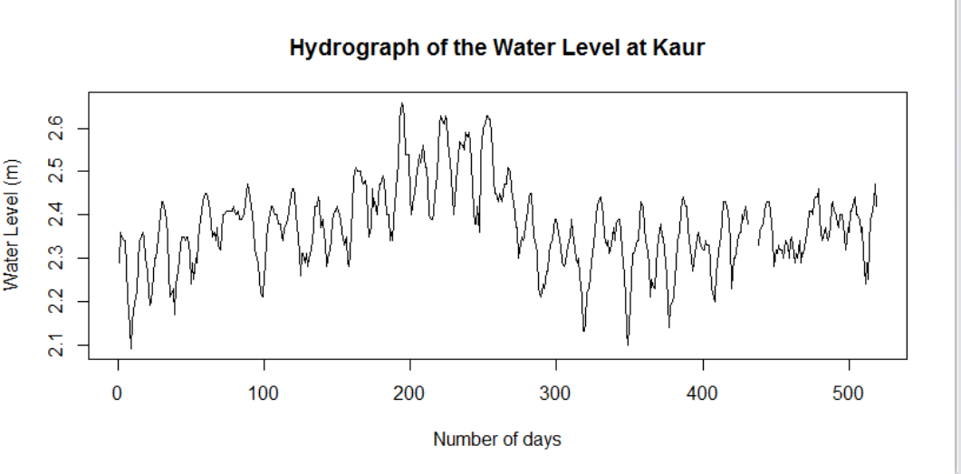
Figure 4a: Hydrograph of the water level at Kaur

The graph shows the maximum daily water level from 20th February, 2015 to 22nd July, 2016. Like other stations lying within the flat flood plain areas, there was a slight upward shift in the water level around day 200 period. After the decline of the flood period, normal flow has been observed

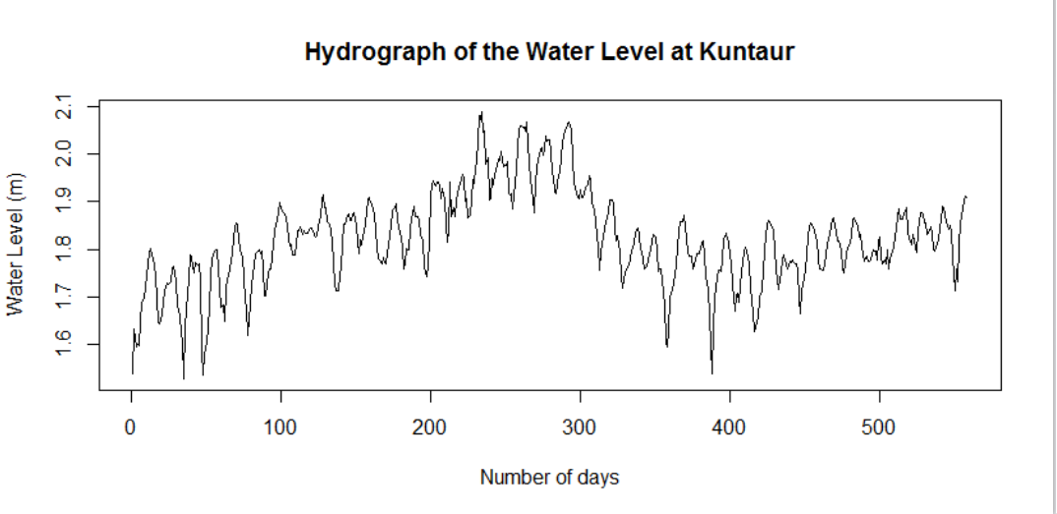
Figure 4b: Hydrograph of the water level at Kuntaur.

The graph shows the maximum daily water level from 12th January, 2015 to 22nd July, 2016. Peak flood was observed from day around 200 to 350, after which the flow returned normal

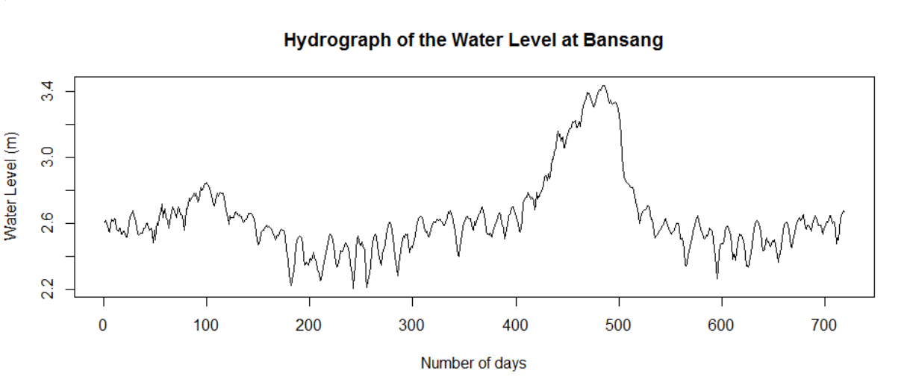

Figure 4c: Hydrograph of the water level at Bansang

The graph shows the maximum daily water level from 19th June, 2015 to 21st July, 2016. The high peak flow on the graph was observed during the 2015 raining season due to the above normal rainfall recorded within the basin. Since the decline of the peak flood in November, normal flow has been observed.

Saline Front Movement
The saline front can be located somewhere between Kaur and Kuntuar. The movement of the saline front this year can be described as slow compared to last year. This is mainly associated to the above normal rainfall observed with the basin. The maximum salinity measured at Kaur in 2015 was 14.92 practical salinity unit (PSU) compared 10.54 PSU in 2016. The early withdrawal of the saline front from Kaur has prevented the salinity reaching Kuntaur the upper limit of the saline from, where the salinity reached last year.
However, salinity is still present at Balingho on the downstream of Kaur, with a measure of about 16.17 PSU. At the same time last year, the station measured 24.30 PSU which was 8.13 units more than this year.

4.0 AGRICULTURAL SITUATION

West Coast Region
The Agricultural situation in this region varies a lot; but major on field activity is ploughing and sowing of upland crops (upland rice, late millet, and maize) and legumes (Groundnut), and few farmers are still engaged in clearing of their fields.

North Bank Region
In this region Agricultural activities also varies a lot, ploughing and planting is on going in the rice fields, crops sown earlier like early millet have germinated and are good looking with weeding in progress in these field.

Lower River Region
N/A

Central River Region North
N/A

Central River Region South
Agricultural activities in this region are affected by the recent flooding. However, efforts are being scaled up by the Agricultural officials on the ground to put up more culverts increase the discharge rate in order to drain the water from the submerged fields. Farmers are trying to harvest and thresh in this situation while in areas where there is no flooding, farmers are busy on birds scaring, harvesting and threshing. Transplanting of Nerica rice and ploughing for groundnut, maize and cowpea is also in progress as well as weeding on some other fields.

Upper River Region
Generally the farmers in the region are busy with plouging and planting of their fields. So far most of the major crops (e.g G/nuts, maize, millet, sorghum and rice) are already sown. Most of these crops are at vegetative stage /phase but planting of these crops is still in progress at lower scale with some late planters. The irrigated rice growing programme is at maturity and in some place is at booting stage.

4.1 COMMODITY PRICES

COMMODITTY PRICE AT URR
Maize = D18.58/Kg
Millet = D45/Kg
Sorghum = D16.72/Kg
Local produced rice = D30.38/Kg
Imp. Broken rice = D22.92/Kg
Imp. Long grain = D32/Kg
Findi = D73. 22/Kg.
Source: Regional Agricultural office Basse URR

4.2 CROP PROTECTION
N/A

4.3 LIVESTOCK
The Livestock situation in the Country has improved due to the availability of feeds and water. In view of that, the following, Clinical treatment figures were obtained during the 3rd dekad of July: CRRS 105 heads of cattle, 120 Sheep, 137 goats, 82 donkeys and 93 horses. In CRRN 206 heads of cattle, 70 Sheep, 145 goats, 92 donkeys and 113 horses. LLR 183 heads of cattle, 97 Sheep, 108 goats, 75 donkeys and 53 horses. NBR,182 cattle, 117 Sheep, 110 goats, 44 donkeys and 130 4horses.URR 187 heads of cattle, 301 Sheep, 143 goats, 67 donkeys and 148 horses. WCR 368 heads of cattle 285 Sheep 347 goats 69 donkeys and 132 horses.
The Department of Livestock Services will not relent in its drive to minimize the debilitating effects of animal diseases in the Country.

5.0 NATIONAL ENVIRONMENT AGENCY (NEA)
N/A

Banjul August 02nd 2016
National MWG of The Gambia

Composition of MWG:  Department of Water Resources  Planning Services - Department of Agriculture (DOA)  Communication, Extension & Education Services - DOA  Department of Livestock Services  Plant Protection Services - DOA  National Environment Agency | Direct your comments and questions to:  The Director  Department of Water Resources  7 Marina Parade, Banjul  The Gambia  Tel: (+ 220) 422 76 31 / 422 41 22 / 890 52 29  Email: dwr@mofwrnam.gov.gm

