EARLY WARNING BULLETIN FOR FOOD SECURITY

No. 2015/07 IN THE GAMBIA Period: July 1-10, 2015

 Government of The Gambia | Produced and Published by The Gambia National Multidisciplinary Working Group  Focal Point: Department of Water Resources  TEL: (+220) 4227631 / 4224122 / 8905229 - FAX: (+220) 422 50 09  E-MAIL: dwr@mofwrnam.gov.gm / WEB: www.mofwrnam.gov.gm

1.0 METEOROLOGICAL SITUATION

SYNOPTIC SITUATION:

The average surface position of the ITD was oscillating over central Mauritania, central Mali and then sloping onto central Niger.

Dry and stable atmosphere prevailed to the north of the ITD with dust haze patches reported over parts of southern Mauritania during first half of the dekad. Conversely convective activities prevailed over much of southern position of the ITD during the dekad.

OUTLOOK FOR THE NEXT DEKAD (July 11st to 20th, 2015)
Mainly variably cloudy atmosphere is expected to prevail with more rains and thunderstorms during the next dekad.

2.0 AGROMETEOROLOGICAL SITUATION

2.1 RAINFALL SITUATION
Significant rainfall amounts were recorded in all the regions of the country during this dekad. Rainfall amounts were highest in the Eastern Third of the country with 195.9mm over Sapu, whilst the lowest amount of 42mm was recorded over Jenoi in the Middle Third of the Country (figure 1a).

Seasonal totals were highest over Sapu with 263.3mm and over Basse with 146.1mm over the Eastern and Middle Thirds respectively. However, seasonal totals were lowest over the Western Third with 27.2mm over Banjul and 29.7mm over Kerewan (Figure 1b).

Figure 1a: Rainfall totals for 1st – 10thJuly 2015.

Figure 1b: Rainfall totals from May 1 2015 – July 10 2015.

2.2 Temperature

Average temperatures across the country varied between 27ºC and 30ºC. Highest temperatures were between 36°C in the Western and Eastern Thirds to 39ºC in the Middle Third.

2.3 Winds

Winds were generally moderate to heavy across the country during this dekad with maximum speed of 64Km/h over Sapu in the Middle Third.

2.4 Sunshine Duration

The average sunshine duration across the country varied between 5 and 7 hours during this dekad.

2.5 Relative Humidity

Relative humidity on average during this dekad was above 60% over the entire country.

3.0 Hydrological Situation

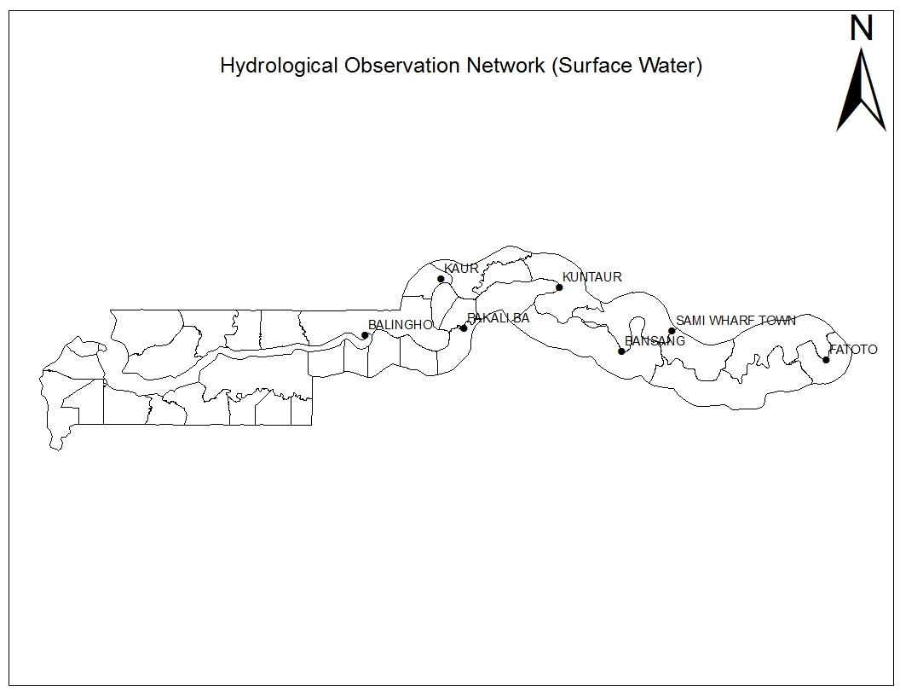
Max: 2.96m
Min: 0.14m
Sal: 31.13 PSU

Max: 2.44m
Min: 0.84m
Sal: 23.22 PSU
Max: 1.92m
Min: 0.59m
Sal: No
Max: 32.765/s
Min: -32.666/s
Max: 2.87m
Min: 0.08m
Sal: No

Max: 1.61m
Min: 0.58m
Sal: 12.57 PSU
Fig 2: The map of the Gambia showing the Hydrological Observation Network

Comments:

Looking at the data closely, we can observe an increase in maximum high tide at Balingho, Bansang and Kuntaur than last month. Salinity level continue to increase at Balingho and Kaur while there was a slight decline at Pakaliba, Bansang and Kuntaur still remains fresh though the specific conductivity at Kuntaur continue to rise.

The maximum discharge recorded at Fatoto was higher than the previous month; this could be attributed to the in-flowing water from the precipitation recorded within the area and beyond.

4.0 AGRICULTURAL SITUATION

WEST COAST REGION
The major Agricultural activity in this region is sowing of some major crops like millet, harvesting of Findi, Maize and Groundnut at the President’s farms in Banjulinding and Jalambang. There is also input distribution (seeds and fertilizers) for farmers in this region during the dekad.

NORTH BANK REGION
Planting of cereals and legumes is in high gears for upland fields, land preparation for land fields is also ongoing. Wet season vegetable production is also in progress.Like in other regions there is input distribution for farmers.

LOWER RIVER REGION
In this region, sowing is in progress for some cereals like early millet and upland rice. There is also input distribution for farmers.

CENTRAL RIVER REGION NORTH
In this region, there is 75% harvesting for rice that were planted during dry season. However, ploughing and transplanting is in progress over rice fields. Upland activities is now the sowing of cereals and leguminous particularly for places like Niani and Sami.

CENTRAL RIVER REGION SOUTH
In this region, harvesting and bird scaring is the main Agricultural activity alongside planting of some local rice varieties. Transplanting is in progress for cereals and leguminous.

4.1 Commodity prices
N/A

4.2 Crop Production
N/A

4.3 LIVESTOCK
The Livestock situation in the country is expected to improve now because the issue of feed scarcity engendered by indiscriminate burning of field trashes and other agronomic malpractices will soon be over. As was reported in the last Deka of June, LRR and NBR are likely to improve later given the nature of the forest cover in those regions.

The menace of Feed scarcity which often poses a major bottle neck in the production and productivity of livestock will soon be a history as grasses and wild fodder trees would have grown very well by mid-August so that once again feed will be abundant in the entire country and Livestock production and productivity will be enhanced.

In URR and some parts of CRR south, two hundred and forty-one (241) animals were treated for a variety of suspected infections. Similarly one hundred and twelve (112) animals were treated in West Coast Region (WCR). However; clinical figures for Lower River Region (LRR), Central River Region (CRR) north and North Bank Region (NBR) were not obtained during the first deka of July. Finally the Livestock situation in all the regions is assumedly going to improve in the coming months.

4.4 Fisheries
N/A

5.0 National Disaster Management Agency (NDMA)
N/A

6.0 National Environment Agency (NEA)
N/A

Banjul July 12th 2015
National MWG of The Gambia

Composition of MWG:  Department of Water Resources  Planning Services - Department of Agriculture (DOA)  Communication, Extension & Education Services - DOA  Animal Health & Production Services - DOA  Plant Protection Services - DOA  National Environment Agency | Direct your comments and questions to:  The Director  Department of Water Resources  7 Marina Parade, Banjul  The Gambia  Tel: (+ 220) 422 76 31 / 422 41 22 / 890 52 29  Email: dwr@mofwrnam.gov.gm

