EARLY WARNING BULLETIN FOR FOOD SECURITY

No. 2017/07 IN THE GAMBIA Period: July 1 - 10, 2017

 Government of The Gambia | Produced and Published by The Gambia National Multidisciplinary Working Group  Focal Point: Department of Water Resources  TEL: (+220) 4227631 / 4224122 / 8905229 - FAX: (+220) 422 50 09  E-MAIL: dwr@mofwrnam.gov.gm / WEB: www.mofwrnam.gov.gm

1.0 METEOROLOGICAL SITUATION
1.1 Synoptic situation
The mean surface position of the ITD, a boundary layer that separates the dry air from the moist humid air has its western axis fluctuating over southern Mauritania, stretching across northern Mali, northern Niger and then sloping onto Chad.

To the north of the ITD, dry and stable atmosphere prevailed with occurrence of dust haze reported over Algeria, central Libya and part of central Ethiopia. However, places to the south of the ITD were generally unstable with marked convective activities resulting to rain showers and thunderstorms precisely over Gulf of Guinea states and much of Sahel region including The Gambia. The occurrences were occasionally widespread and associated with strong winds.

1.2 Weather summary for The Gambia
Warm, humid and convective activities characterized the weather which resulted to rain showers and thunderstorms, occasionally widespread and associated strong winds during the last dekad over the entire country.

1.3 Outlook for the next dekad (July 11th to 20th, 2017)
Warm and humid atmosphere will prevail with enhanced precipitation over the country during the period. Moderate to heavy rains and thunderstorms, occasionally associated with strong winds are expected to affect the country through the first half of the dekad, particularly on the 13th and the evening of 15th July 2017 towards early next day. The rest of the dekad will continue to experience isolated to scattered sporadic outbreak of rain showers and thunderstorms.

2.0 AGROMETEOROLOGICAL SITUATION
2.1 Rainfall situation
The rainfall situation during this dekad has improved significantly in most parts of the country. Dekadal rainfall amounts were highest in the Western Third of the country with over 90mm recorded over Yundum and Sere Kunda (figure 1a).

Seasonal totals recorded were highest over Sapu in the Middle Third with 350.1mm. In the Western Third, Sere Kunda recorded 187.6mm, while 159.9mm was recorded over Basse in the Eastern Third of the country (figure 1b).

Figure 1a: Rainfall totals for 1st – 10thJuly 2017.

Figure 1b: Rainfall totals from May 1, 2017 – July 10, 2017.

The Country average as of 10th July 2017, stands at 153.6 mm, 157% above the country average for last year (10th July 2016; 59.6mm), and 22.3% above the long term mean (1981-2010; 125.5mm).

2.3 Temperature
Average temperatures across the country varied between 26ºC in the Western Third and 29ºC over the rest of the country. Highest temperatures were between 34°C in the Western and 37ºC in rest of the country.

2.4 Winds
Winds were moderate to strong throughout the country during the dekad. Very strong winds of 83km/h were recorded over the Western Third resulting to structural damages and human casualty, as a woman lost her life after a tree fell on a passenger car she was in. This happens on the 08th July 2017 when a thunderstorm hit the area.

2.5 Relative Humidity

Relative humidity on average during this dekad was above 60% over the entire country depicting high moisture content in the atmosphere favoring more rains to come.

3.0 Hydrological Situation

3.1 Surface water level

During the month of June, the highest water levels of more than 2.0m were registered at Kaur and Bansang whilst the lowest (1m) was at Basse (figure 2). However, compared to the preceding month water levels demonstrated decrease by 0.02m at Tendaba, Sami-Tenda and Basse. The rest of the network sites registered increase in water levels.

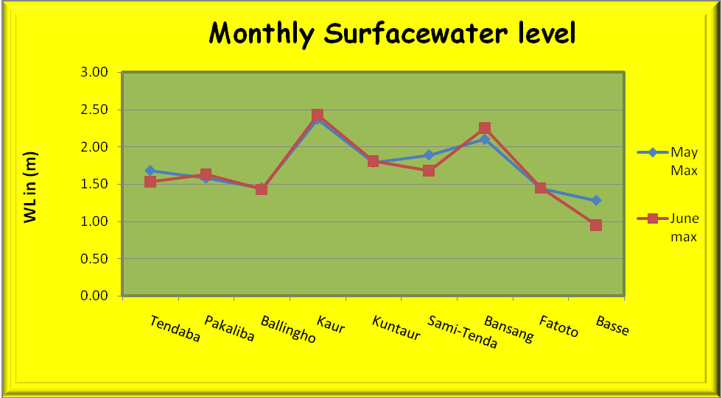
Figure 2: Monthly surface water levels

3.2 Ground water level

Generally figure 3.0 below illustrated that ground water levels at two of the monitoring sites has dropped slightly such as: Brikama (OB1) by 0.94m, Kantele Kunda by 0.36m. These two sites registered highest dropped within the whole groundwater network, while others dropped by less than 0.06. Water level has rise at some points such as: Fajara (TB8) by 0.82m; Ndungu Kebbeh by 0.69m; Pakaliba by 0.45m; Denton Boiram by 0.19m; Gunjur by 0.16m respectively while others increase by less than 0.10m.

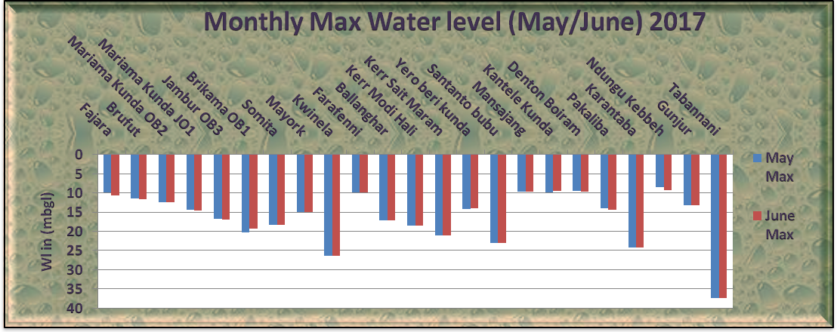

Figure 3.0: Monthly maximum water level (May/June 2017)

3.3 Salinity
During this recent (in June 2017) download, the saline interface was observed at 222km from Banjul. Kaur recorded salinity concentration of 7.08psu compared to 4.35psu during May 2017. It’s important to mention that Kuntaur observed zero salinity for the entire season.

4.0 AGRICULTURAL SITUATION

WEST COAST REGION
Major Agricultural activities in this region are clearing and sowing of major crops in the upland. Ploughing and nursery preparation in the lowland fields is ongoing. Few farmers are still engaged in harvesting of some vegetable crops.

NORTH BANK REGION
In this region, planting of cereals (early millet, maize and rice); and legumes (groundnut) is still in progress for upland fields, some crops have already germinated and some farmers are busy on tine cultivation. Land preparation is still in progress for upland and some lowland fields.

LOWER RIVER REGION
In this region, the dominant activity is sowing of major crops: early millet, maize rice and groundnut. Some crops have germinated and are doing well. There is still ploughing in the lowland, although this activity is delayed due to limited ploughing equipment.

CENTRAL RIVER REGION NORTH
Like other regions, planting of all major crops (maize, early millet, sorghum and groundnuts) is ongoing and some crops have started germinating. Transplanting of rice from nursery fields to permanent fields is also in progress.

CENTRAL RIVER REGION SOUTH
The main agricultural activities in this region are harvesting of rice, bird scaring, transplanting of local rice variety as well as ploughing and nursery preparation in the lowland fields, whilst in the upland fields, farmers are busy on planting of cereals and tine cultivation in already germinated fields.

UPPER RIVER REGION
N/A

4.1 Crop Protection

No major pest outbreak reported in the country during the period under review.

5.0 LIVESTOCK

The Livestock situation in the Country is not impressive as greater part of the grazing fields have been cleared and sowed by farmers as part of their activities in the rainy season. This often deprived Livestock access to adequate feeds. This exercise is likely to increase the number of clinical cases due to the warm weather which is conducive for some disease vectors. In view of that, clinical treatments figures are likely to rise. The following clinical cases were seen during the Month of June 2017. CRRS 152 heads of cattle, 131 Sheep 108 goats, 21 donkeys and 43 horses. In CRRN 271 heads of cattle 119 sheep 123 goats, 7 donkeys and 18 horses. LRR 129 heads of cattle, 154 Sheep, 205 goats, 11 donkeys and 15 horses. NBR, 132 cattle, 211 Sheep, 93 goats, 17 donkeys and 28 horses.URR 254 heads of cattle, 182 Sheep, 101 goats 41 donkeys and 12 horses. WCR 263 heads of cattle 112 Sheep 207 goats 5 donkeys and 39 horses.

Banjul July 12th 2017
National MWG of The Gambia

Composition of MWG:  Department of Water Resources  Planning Services - Department of Agriculture (DOA)  Communication, Extension & Education Services - DOA  Department of Livestock Services  Plant Protection Services - DOA  National Environment Agency | Direct your comments and questions to:  The Director  Department of Water Resources  7 Marina Parade, Banjul  The Gambia  Tel: (+ 220) 422 76 31 / 422 41 22 / 890 52 29  Email: dwr@mofwrnam.gov.gm

